

Software Engineering Department
Braude College

Capstone Project Phase B

Impact of subliminal perception on motor planning

25-2-D-1

Students:
Daniel Shahar
Rachel Avidan-King

Mentors:
Dr. Anat Dahan
Dr. Marcos Hilsenrat

**https://github.com/RachelAvidanKing/Capstone-Project-App

Table of Contents
1 Table of Contents 2
2 Abstract 3
3 Introduction 3
4 Problem Statement & Objectives 3
5 System Requirements 5
6 System Architecture & Design 7
7 System Operation & Workflow 9
8 Data Management & Security 11
9 Data Analysis Pipeline 13
10 Challenges & Solutions 16
11 Results & Discussion 17
12 Conclusion & Future Work 23
13 Appendix A – User Guide (Android App) 25
14 Appendix B – User Guide (Web Interface) 35
15 Appendix C – Maintenance Guide 49

Abstract
This capstone project presents an end-to-end software system designed to investigate how subliminal and suprathreshold visual cues influence goal-directed reaching movements. While traditional motor behavior research relies on specialized laboratory hardware, this project demonstrates a mobile-first approach using an Android-based data collection tool integrated with a secure cloud-based Firebase backend and a Python analysis pipeline. The system features an individualized calibration process using Just Noticeable Difference (JND) to establish perceptual thresholds for each user. Experimental results indicate that cue timing and perceptual salience significantly influence motor preparation and execution, though individual variability remains a factor. Ultimately, this project proves the feasibility of using modular, mobile software frameworks to conduct rigorous behavioral neuroscience research outside of traditional lab settings.

Introduction
Human perception and motor behavior are tightly coupled processes, often operating under time constraints that limit conscious awareness. While research has shown that subliminal stimuli—information presented below the threshold of conscious perception—can influence decision-making, its specific impact on the mechanics of motor planning remains under-investigated.
Studying this interaction presents significant methodological challenges, requiring precise stimulus timing and individualized calibration. Traditional setups are often expensive and non-portable, limiting the scalability of behavioral research. There is a growing need for flexible, software-driven platforms that can maintain experimental rigor on consumer-grade hardware.
This project addresses these challenges by developing a robust, end-to-end experimental framework. The system replaces specialized lab equipment with a Kotlin-based Android application for data collection and a Python-based pipeline for automated analysis. By leveraging the Entity–Control–Boundary (ECB) architectural pattern and cloud-based synchronization, the project ensures data integrity while providing a modular tool for researchers.
The primary goal is to provide a reusable research tool that bridges the gap between experimental neuroscience and practical software engineering. This document details the system’s design, the implementation of the JND calibration procedure, and an analysis of how visual cues ultimately shape movement behavior.

Problem Statement & Objectives

Problem Statement
Research investigating the influence of subliminal perception on motor planning requires highly controlled experimental conditions and precise data acquisition. Specifically, such studies depend on accurate determination of individual perceptual thresholds, strict temporal control over stimulus presentation, and reliable measurement of movement-related parameters such as reaction time, trajectory, and execution duration. Achieving all of these simultaneously presents a substantial technical challenge.
Existing experimental setups in this domain often rely on specialized laboratory hardware and custom-built software, which can be costly, difficult to maintain, and inaccessible outside controlled lab environments. Furthermore, many solutions lack flexibility in adapting experiments to individual participants, particularly with respect to personalized perceptual thresholds such as the Just Noticeable Difference (JND). This limitation may introduce noise into experimental results and reduce the validity of comparisons across participants.
From a software perspective, additional challenges arise in managing experimental workflow, ensuring data integrity, and securely storing sensitive participant information. Experimental data is typically collected across multiple stages, often involving interruptions, retries, or partial completion, which must be handled without data loss or corruption. Moreover, integrating data collection with downstream analysis and visualization tools is frequently an ad hoc process, increasing the risk of inconsistencies and errors.
Finally, there is a lack of unified, end-to-end systems that combine experiment execution, secure data storage, and flexible post-hoc analysis within a single, coherent framework. This fragmentation complicates replication, limits scalability, and places a high technical burden on researchers who may not have extensive software engineering expertise.

Objectives
The primary objective of this capstone project is to design and implement a complete software system that enables controlled investigation of the effects of subliminal visual cues on reaching movements, while addressing the technical and methodological challenges outlined above.
To achieve this goal, the project defines the following specific objectives:
- Develop a mobile-based experimental application that guides participants through registration, perceptual threshold determination, and execution of reaching movement trials in a structured and user-friendly manner.
- Implement a personalized JND-based thresholding mechanism, ensuring that subliminal and suprathreshold stimuli are defined relative to each participant’s individual perceptual capabilities.
- Provide precise control over experimental timing and trial conditions, enabling consistent presentation of visual and auditory cues across multiple experimental paradigms.
- Ensure reliable and secure data management, including local persistence of experimental data, fault-tolerant background synchronization, and secure cloud-based storage.
- Design a modular and maintainable software architecture, facilitating future extension, debugging, and reuse in related experimental contexts.
- Develop an analysis pipeline for post-processing and visualization, allowing researchers to explore behavioral metrics across experimental conditions and participant demographics.

Success Criteria
The success of the project is evaluated based on the following criteria:
- The system successfully conducts the full experimental workflow, from participant login to experiment completion, without data loss or workflow inconsistencies.
- Individual perceptual thresholds (JND values) are reliably calculated and used to determine stimulus presentation conditions during the reaching movement task.
- Experimental data, including timing and movement metrics, is accurately recorded and securely stored for later analysis.
- The system supports flexible data analysis and visualization, enabling comparison between different experimental conditions (e.g., subliminal, suprathreshold, and concurrent cues) and participant groups.
- The software architecture demonstrates clarity, modularity, and robustness, reflecting sound software engineering principles.

System Requirements
This section defines the functional and non-functional requirements of the system developed in this project. These requirements were derived from the experimental goals, technical constraints, and feedback obtained during early testing phases. Together, they ensure that the system supports reliable experimental execution, secure data handling, and effective data analysis.

4.1 Functional Requirements
The system shall provide the following functional capabilities:
- Participant Identification and Access Control
The system shall allow participants to log in using a unique 9-digit identifier. The system shall recognize returning participants and adapt the workflow according to their experiment completion status.
- Participant Registration and Data Collection
The system shall enable participants to enter demographic and experimental metadata, including age, gender and vision-related information.
- Personalized Perceptual Threshold Determination
The system shall implement a Just Noticeable Difference (JND) assessment using a forced-choice paradigm, enabling calculation of an individualized perceptual threshold for each participant.
- Guided Experimental Workflow
The system shall guide participants through all required stages of the experiment, including explanations, practice trials, and experimental trials, while preventing invalid progression or repeated execution of completed stages.
- Reaching Movement Experiment Execution
The system shall conduct reaching movement trials under multiple experimental conditions, including:
  - Subliminal pre-cue presentation (PRE_JND)
  - Suprathreshold pre-cue presentation (PRE_SUPRA)
  - Concurrent suprathreshold cue presentation (CONCURRENT_SUPRA)
- Accurate Data Capture
The system shall record detailed behavioral and timing data for each trial, including reaction time, movement time, trajectory path, path length, target index, and response timestamps.
- Local Data Persistence
The system shall store all experimental data locally on the device using a structured database to ensure data integrity during offline operation or unexpected interruptions.
- Cloud-Based Data Synchronization
Upon experiment completion, the system shall automatically upload participant data to a centralized cloud database for long-term storage and analysis.
- Fault-Tolerant Data Upload
The system shall support background retries for failed data uploads, ensuring eventual synchronization without requiring user intervention.
- Data Analysis and Visualization Support
The system shall provide tools for extracting, cleaning, analyzing, and visualizing experimental data across participants and experimental conditions.

4.2 Non-Functional Requirements
The system shall satisfy the following non-functional requirements:
- Platform Compatibility
The application shall operate on the Android operating system and be optimized for a specific tablet device to ensure consistent stimulus presentation and input handling.
- Performance
The system shall present visual and auditory stimuli with minimal latency and ensure smooth interaction during experimental trials. Screen transitions and response handling shall not interfere with experimental timing.
- Usability
The user interface shall be intuitive and require minimal instruction, enabling participants to complete the experiment independently following on-screen explanations.
- Data Integrity
The system shall ensure that experimental data is consistently recorded, correctly associated with participants, and protected from duplication or corruption.
- Security and Privacy
Participant data shall be securely stored and transmitted using authenticated access mechanisms. Sensitive configuration files and credentials shall not be exposed within the application or version control system.
- Maintainability and Extensibility
The system architecture shall support future modifications, including new experimental conditions, additional participant attributes, or extended analysis capabilities, without major restructuring.

System Architecture & Design
This section describes the overall architecture of the system developed in this project, including its main components, architectural patterns, and data flow. The system was designed to support a complete experimental pipeline, from participant interaction and data acquisition on a mobile device to secure cloud storage and offline data analysis.

High-Level System Architecture
At a high level, the system consists of three main components:
- Android-based Experimental Application
Responsible for participant interaction, experiment execution, and initial data collection.
- Cloud-Based Data Storage (Firestore Database)
Used for centralized, secure storage of completed experimental data.
- Python-Based Data Analysis Pipeline
Used for data extraction, cleaning, analysis, and visualization following data collection.
The Android application operates as the primary data acquisition tool. Experimental data is first stored locally on the device to ensure reliability and offline support. Upon completion of the experiment, the data is automatically synchronized to the cloud database. The analysis pipeline then retrieves the stored data for further processing and exploration.
This separation between data collection and data analysis allows each component to evolve independently while maintaining a clear and well-defined interface between them.

Architectural Pattern
The Android application was implemented using the Entity–Control–Boundary (ECB) architectural pattern. This pattern was selected due to its suitability for interactive systems with complex workflows and its ability to clearly separate responsibilities between user interaction, business logic, and data representation. The ECB pattern improves code readability, facilitates testing, and simplifies maintenance by reducing coupling between the user interface and underlying logic.

Boundary Layer
The Boundary layer consists of Android Activities and ViewModels responsible for interacting with participants and presenting the experimental workflow. These components handle user input, screen navigation, and presentation of instructions and stimuli, while delegating logic and data handling to the Control layer.
The Boundary package includes the following components:
- LoginActivity – Handles participant identification using a unique 9-digit ID.
- RegistrationActivity – Collects participant demographic.
- ExplainJNDActivity – Presents instructions for the perceptual threshold task.
- ThresholdActivity – Manages the JND determination task interface.
- ExplainTargetActivity – Provides instructions for the reaching movement experiment.
- TargetActivity – Executes the reaching movement trials and captures interaction data.
- CompletionActivity – Displays experiment completion and thank-you messages.
- TargetViewModel – Maintains UI-related state and supports lifecycle-safe data handling.
By isolating presentation logic in the Boundary layer, the system ensures that UI changes do not affect core experimental logic.

Control Layer
The Control layer coordinates the system’s core logic, experiment flow, and background processes. It acts as an intermediary between the Boundary and Entity layers, ensuring that data is processed consistently and experimental constraints are enforced.
The Control package includes the following components:
- TargetController – Manages the logic of the reaching movement experiment, including trial sequencing and condition handling.
- ThresholdController – Controls the execution and evaluation of the JND determination process.
- MovementTracker – Collects and processes movement-related data such as trajectory paths and timing metrics.
- DataRepository – Serves as the central access point for reading and writing experimental data.
- DataUploadWorker – Handles background synchronization of completed experiment data to Firebase.
- WorkScheduler – Schedules deferred upload attempts in case of network failures.
- InactivityHelper – Detects participant inactivity and enforces experimental constraints.
- DebugHelper – Provides logging and debugging support during development and testing.
This layer encapsulates all decision-making logic, ensuring that experimental rules are enforced consistently across different UI states and device conditions.

Entity Layer
The Entity layer defines the system’s data model and persistence mechanisms. It includes representations of participants, trials, and experimental results, as well as access interfaces for local data storage.
The Entity package includes:
- Participant – Represents participant demographic and experimental metadata.
- TargetTrialResult – Represents the data collected during a single reaching movement trial.
- AppDatabase – The Room database instance managing local persistence.
- ParticipantLocalDataSource (DAO) – Provides database access for participant data.
- TargetTrialLocalDataSource (DAO) – Provides database access for trial-level data.
Local persistence is implemented using the Android Room library, enabling structured storage, compile-time query validation, and lifecycle-aware data access.

Application-Level Components
Outside the ECB package structure, the system includes the CapstoneApplication class, which serves as the application-level entry point. This component is responsible for initializing global resources, configuring background workers, and preparing database and network dependencies upon application startup.

Data Flow and Persistence Strategy
Experimental data follows a staged persistence strategy to maximize reliability:
- During experiment execution, all data is stored locally in the Room database.
- Upon full completion of the experiment, a background worker initiates data upload to Firebase Firestore.
- If the upload fails due to network or service issues, the system schedules automatic retry attempts.
- Once uploaded, data is stored under a participant-specific document, with trial data organized as a subcollection.
This approach ensures that data is not lost due to application termination, device rotation, or temporary connectivity issues.

Design Rationale
The architectural design decisions made in this project were guided by the following principles:
- Reliability: Local-first data storage prevents loss of experimental results.
- Modularity: Clear separation of concerns supports maintainability and extension.
- Scalability: Cloud-based storage enables centralized analysis across participants.
- Research Integrity: Controlled experiment flow and data handling ensure reproducible results.
Together, these design choices enable the system to function as a robust research tool rather than a one-off prototype

System Operation & Workflow
This section describes the operational flow of the system from the moment a participant launches the application until experimental data is fully recorded and prepared for analysis. The workflow was designed to ensure experimental consistency, prevent invalid states, and support participants with minimal external guidance.

Participant Entry and Identification
Upon launching the application, participants are presented with a login screen requesting a unique 9-digit identifier. This identifier is used to retrieve the participant’s experimental status from the local database and determine the appropriate workflow path.
If a participant has already completed the full experiment, the system immediately displays a completion screen thanking the participant and prevents re-entry into the experimental flow. This mechanism ensures that each participant contributes data only once, maintaining data validity.
For participants who have not yet completed the experiment, the system determines which stages—if any—have already been completed and resumes the workflow from the appropriate point.

Registration and Metadata Collection
New participants are guided to a registration screen where demographic and experimental metadata are collected. This includes age, gender, consent confirmation (implicitly assumed when the participant presses on the next button), and additional attributes relevant to later analysis, such as visual correction usage or attention-related conditions.
The registration process must be completed before any experimental tasks are unlocked. All collected data is stored locally and associated with the participant’s identifier.

Perceptual Threshold (JND) Determination
Following registration, participants are presented with an explanation screen introducing the perceptual threshold task. The Just Noticeable Difference (JND) determination is conducted using a two-alternative forced-choice paradigm.
Participants are shown pairs of color stimuli that differ subtly in hue and are required to select which stimulus appears brighter. The task consists of a fixed number of trials (100), with randomized stimulus presentation to prevent learning effects or bias.
The system tracks participant responses across trials and computes an individualized JND value upon completion. This threshold is then stored and used to determine subliminal stimulus condition in subsequent experimental stages.
If a participant has already completed the JND determination in a previous session, this stage is skipped, and the workflow continues directly to the next phase.

Reaching Movement Experiment
After the perceptual threshold has been determined, participants are introduced to the reaching movement experiment through a dedicated explanation screen. This step was added following beta testing to ensure participants clearly understand the task requirements.
The experiment begins with a single practice trial, allowing participants to familiarize themselves with the interaction and timing. This is followed by a sequence of fifteen experimental trials.
Each trial involves the presentation of four potential targets on the screen, accompanied by a sequence of auditory cues. Depending on the trial condition, the target stimulus is presented:
- Below the participant’s JND threshold prior to the final auditory cue (PRE_JND)
- Above the perceptual threshold prior to the final auditory cue (PRE_SUPRA)
- Concurrently with the final auditory cue at a suprathreshold level (CONCURRENT_SUPRA)
Participants are instructed to initiate a reaching movement toward the target as quickly as possible after the final (fourth) auditory cue.

Trial Execution and Data Capture
During each reaching movement trial, the system records detailed temporal and spatial data. This includes reaction time, movement onset, trajectory path, path length, target selection, and response timestamps.
The system ensures that all trial data is saved immediately to the local database upon completion of each trial. In the event of interruptions such as screen rotation or temporary application backgrounding, the system preserves the current experimental state and prevents loss of data or unintended trial resets.

Experiment Completion and Data Synchronization
Once all experimental trials have been completed, the participant is shown a completion screen confirming successful participation. At this stage, the system marks the experiment as complete for the participant.
A background synchronization process is then initiated to upload the participant’s data to the cloud-based database. If network connectivity is unavailable, the upload is deferred and retried automatically later without requiring participant intervention.

Post-Experiment Data Availability
After data synchronization, participant data becomes available for retrieval by the analysis pipeline. Data is organized by participant identifier and includes both demographic metadata and detailed trial-level results.
This structured workflow ensures that experimental data is consistently collected, securely stored, and readily available for downstream analysis.

Data Management & Security
This section describes the strategies and mechanisms used to manage experimental data throughout its lifecycle, from local acquisition on the mobile device to secure cloud storage and post-experiment analysis. Emphasis was placed on data integrity, fault tolerance, and protection of sensitive information.

Local Data Management
All experimental data is initially stored locally on the Android device using a structured Room database. This design choice ensures that data collection remains reliable even in the absence of network connectivity and protects against data loss caused by unexpected application termination.
Participant metadata and trial-level data are stored in separate but related tables, allowing efficient queries and clear separation between demographic information and experimental results. Each trial is written to the database immediately upon completion, ensuring that partial progress is preserved if the experiment is interrupted.
Local-first persistence also enables the system to manage complex experimental workflows, including conditional progression and state recovery, without relying on external services.

Cloud Data Storage
Upon successful completion of the experiment, participant data is synchronized to a cloud-based database implemented using Firebase Firestore. Firestore was selected due to its scalability, document-oriented structure, and seamless integration with Android applications.
In Firestore, data is organized under a dedicated participants collection. Each participant is identified by their unique 9-digit identifier and stored as a document containing demographic and experimental metadata. Trial-level data is stored within a subcollection, enabling efficient aggregation and retrieval during analysis.
This hierarchical structure supports scalable analysis across participants while preserving a clear association between participant metadata and experimental results.

Fault Tolerance and Data Integrity
To ensure robustness, the system implements a fault-tolerant data synchronization mechanism. Data uploads are handled by a background worker that operates independently of the user interface. If an upload attempt fails due to network unavailability or service issues, the system schedules automatic retries at a later time.
This mechanism ensures eventual consistency between local and cloud data stores without requiring participant intervention. Additionally, safeguards were implemented to prevent duplicate uploads and to mark experiments as completed only after all required data has been successfully recorded locally.
During development and testing, instances of corrupted or duplicated cloud data were identified, highlighting the importance of defensive data handling. These experiences informed the design of the data cleaning and validation processes used during analysis.

Data Security Measures
Protecting participant data was a central concern throughout the project. Several security measures were implemented to prevent unauthorized access and exposure of sensitive information.
Access to the cloud database is restricted through Firebase security rules, ensuring that only authenticated and verified application instances can write data. Firebase App Check was used to verify the integrity of the application making requests to Firestore, reducing the risk of unauthorized or malicious data submission.
Sensitive configuration files and credentials, including service account keys, were excluded from version control using .gitignore. Early development mistakes involving accidental exposure of sensitive files in the repository required corrective actions, including commit history cleanup and regeneration of compromised credentials.
Additionally, the application was distributed using a signed APK, ensuring that only trusted builds of the application could be installed and used for data collection.

Version Control and Repository Management
The project was maintained in a single Git repository containing both the Android application and the Python analysis scripts. While this approach provided a centralized view of the entire system, it introduced challenges related to environment separation, branching, and dependency management.
Managing Kotlin and Python codebases within the same repository required careful use of directory structure and .gitignore configuration. Early difficulties with branching and merging highlighted the learning curve associated with professional version control workflows.
Despite these challenges, the repository structure ultimately enabled supervisors to review the complete project in a unified context, and the experience provided valuable practical insight into real-world software development practices.

Data Analysis Pipeline
This section describes the data analysis pipeline developed to process, validate, and analyze the experimental data collected by the mobile application. The pipeline was implemented in Python and designed to support reproducible analysis, flexible exploration of experimental conditions, and automated generation of visualizations and reports.
The analysis logic is shared across both command-line execution and a web-based interface, allowing the same analytical workflow to be accessed programmatically or interactively without duplication of code.

Overview of the Analysis Pipeline
The analysis pipeline operates independently of the data collection application and is executed after experimental data has been uploaded to the cloud database. Its primary responsibilities include:
- Retrieving participant and trial data from the cloud database
- Detecting and correcting data inconsistencies
- Computing behavioral metrics across experimental conditions
- Testing predefined experimental hypotheses
- Generating plots and summary outputs for interpretation
Separating data analysis from data collection enables modular development and allows the experimental application and analysis tools to evolve independently.

Data Retrieval and Connectivity
Data is retrieved from Firebase using a dedicated Python connector module. This component establishes an authenticated connection to the database and downloads participant documents along with their associated trial subcollections.
To improve efficiency and reliability, retrieved data is cached locally, enabling repeated analyses without redundant network requests. This approach also allows offline experimentation with analysis parameters and visualization styles.

Data Cleaning and Validation
During early testing phases, issues such as duplicated trials and inconsistent participant records were observed, primarily due to repeated upload attempts or interrupted experiment sessions. To address this, a dedicated data cleaning script was developed.
The cleaning process includes:
- Detection of duplicate trials based on participant identifiers and trial numbers
- Removal or consolidation of redundant records
- Validation of expected trial counts and condition distributions
This step ensures that downstream analyses are performed on consistent and reliable datasets, reducing noise and preventing misleading results.

Experimental Conditions and Metrics
Each trial is associated with one of three experimental conditions:
- PRE_JND: Subliminal cue presented at the participant’s JND threshold prior to the go signal
- PRE_SUPRA: Suprathreshold cue presented prior to the go signal
- CONCURRENT_SUPRA: Suprathreshold cue presented concurrently with the go signal
For each trial, the pipeline computes and aggregates key behavioral metrics, including reaction time, movement duration, path length, average movement speed, and total response time. These metrics serve as the primary basis for comparing participant performance across conditions.

Hypothesis Testing and Comparative Analysis
The primary hypothesis investigated in this project posits that motor responses will differ systematically across experimental conditions, with performance metrics following the expected relationship:
PRE_SUPRA < PRE_JND < CONCURRENT_SUPRA
in terms of reaction time and movement efficiency.
The analysis pipeline groups trial data by condition and participant, enabling both within-subject and between-group comparisons. In addition to overall comparisons, the pipeline supports segmentation of data by demographic attributes such as age, gender, and vision-related characteristics.

Visualization and Reporting
The pipeline generates a variety of visual outputs to support interpretation of results. These include:
- Distribution plots of reaction time and movement metrics
- Condition-wise comparisons across participants
- Demographic subgroup analyses
- Summary plots highlighting aggregate trends
Visualizations are generated programmatically as part of the analysis process. Depending on the execution mode, plots may be saved to disk for offline inspection or served dynamically to an interactive user interface. This approach ensures consistent reproduction of results while supporting exploratory analysis.

Interactive Analysis Interface
In addition to script-based execution, the analysis pipeline is exposed through an interactive web-based interface. A Python backend server provides a REST API that allows users to trigger analysis tasks and retrieve results without modifying source code.
Through this interface, users can:
- Test database connectivity
- View summary statistics and dataset characteristics
- Execute full analyses and hypothesis tests
- Generate and view plots interactively
- Export raw and processed datasets
- Reload cached data or clean existing records
The web interface acts as a presentation layer only; all analytical logic remains within the Python pipeline. This design lowers the barrier to entry for researchers and supervisors while preserving reproducibility and centralized control of analysis behavior.

Design Considerations
The analysis pipeline was designed with the following principles in mind:
- Reproducibility: Automated data retrieval and plotting ensure consistent results.
- Flexibility: Modular scripts support extension and customization.
- Robustness: Explicit data validation prevents silent errors.
- Separation of concerns: Analysis logic is decoupled from data collection.
Together, these design choices enable reliable and extensible analysis of experimental data while supporting both programmatic and interactive use.

Challenges & Solutions
Throughout the development of this project, multiple technical and methodological challenges were encountered. These challenges arose from the complexity of integrating experimental requirements with mobile application development, cloud-based data management, and post-hoc analysis. This section outlines the most significant challenges and the solutions adopted to address them..

Ensuring Participant Understanding and Task Compliance
Challenge:
Initial beta testing revealed that participants often misunderstood task instructions, particularly during the reaching movement experiment. Verbal explanations alone proved insufficient, leading to incorrect task execution and increased variability in the collected data.
Solution:
Dedicated explanation screens were added before both the perceptual threshold task and the reaching movement experiment. These screens provided clear, step-by-step instructions and visual cues, enabling participants to perform the tasks independently. A practice trial was also introduced prior to the main experimental trials, significantly improving task comprehension and consistency.

Data Loss and Experiment Reset Bugs
Challenge:
Several critical bugs were encountered during development, including unintended resets of JND calculations and experimental trials. In some cases, participants were required to restart lengthy tasks due to screen rotation or minor interaction issues, negatively impacting usability and data collection.
Solution:
These issues were resolved by improving state persistence mechanisms and introducing stricter validation of experiment progression. Trial data was saved immediately upon completion, and experiment flow logic was reinforced to prevent reinitialization of completed stages. Extensive testing across device orientations and usage scenarios was conducted to verify stability.

Cloud Integration and Data Duplication
Challenge:
Integrating Firebase for cloud storage introduced challenges related to authentication, security configuration, and data consistency. During early deployments, repeated upload attempts resulted in duplicated trial records for some participants, complicating downstream analysis.
Solution:
A fault-tolerant upload mechanism was implemented using background workers and deferred retries. Safeguards were added to prevent duplicate uploads by tracking completion state and validating trial counts. On the analysis side, a dedicated data cleaning script was developed to detect and correct duplicated records, ensuring reliable datasets for hypothesis testing.

Securing Sensitive Configuration and Application Distribution
Challenge:
Early in development, sensitive configuration files and credentials were mistakenly committed to the version control repository, posing a significant security risk. Additionally, distributing unsigned application builds raised concerns regarding application integrity and unauthorized use.
Solution:
All sensitive files were removed from version control, and the repository history was cleaned to eliminate exposed credentials. New service account keys were generated, and a strict .gitignore policy was enforced. The application was subsequently distributed as a signed APK, ensuring that only trusted builds could be used for data collection.

Version Control and Multi-Environment Development
Challenge:
The project combined Kotlin-based Android development and Python-based data analysis within a single repository. Managing different environments, dependencies, and branching strategies proved challenging, particularly during early attempts to separate features across branches.
Solution:
The repository structure was reorganized to clearly separate application and analysis components. Branching practices were simplified, and feature development was consolidated where appropriate. Over time, these adjustments improved workflow stability and provided valuable experience with professional version control practices.

Lessons Learned
The challenges encountered throughout this project underscored the importance of robust state management, defensive data handling, and clear user guidance in experimental software. Addressing these issues not only improved system reliability but also deepened understanding of mobile application development, cloud security, and reproducible data analysis.

Results & Discussion
This subsection presents general behavioral results across all participants, focusing on core movement and timing metrics independent of demographic segmentation. The aim is to establish baseline trends and provide context for subsequent comparisons between experimental conditions.

Dataset Overview
Data was collected from participants who completed the full experimental workflow, including registration, JND determination, and the reaching movement experiment. For each participant, a fixed number of experimental trials were recorded following an initial practice trial.
Prior to analysis, the dataset was validated and cleaned using the dedicated data cleaning tools described in the Data Analysis Pipeline section. This process ensured consistency in trial counts and removed duplicated or corrupt records.
Metrics analyzed included:
- Reaction Time (RT):
Defined as the interval between the GO signal and the initiation of movement. RT reflects the efficiency of motor planning and response preparation.
- Movement Duration:
Measured as the time from movement onset to target acquisition, indicating execution efficiency.
- Path Length and Trajectory:
Calculated from the recorded (x, y) coordinates throughout each trial. These metrics reflect movement directness and control.
- Average Movement Speed:
Derived from path length divided by movement duration, providing an overall measure of movement vigor.
These metrics were automatically extracted from raw trial data using the analysis pipeline described in Chapter 8. In addition to trial-level data, participant metadata such as age, gender, and vision-related attributes were recorded, enabling segmented analysis.

Comparison Across Experimental Conditions
The primary research focus of this study is the comparison between experimental cueing conditions. Accordingly, behavioral metrics were compared across the following conditions:
- PRE_JND: subliminal cue presented prior to the GO signal
- PRE_SUPRA: suprathreshold cue presented prior to the GO signal
- CONCURRENT_SUPRA: suprathreshold cue presented concurrently with the GO signal
Across participants, reaction time differences were observed between conditions. Pre-cued suprathreshold trials generally resulted in faster reaction times compared to concurrent cue presentation, consistent with existing literature on advance motor preparation. Subliminal pre-cue trials often produced intermediate reaction times.
These results suggest that both cue timing and perceptual salience influence motor preparation, supporting the hypothesis that advance cueing facilitates movement initiation.
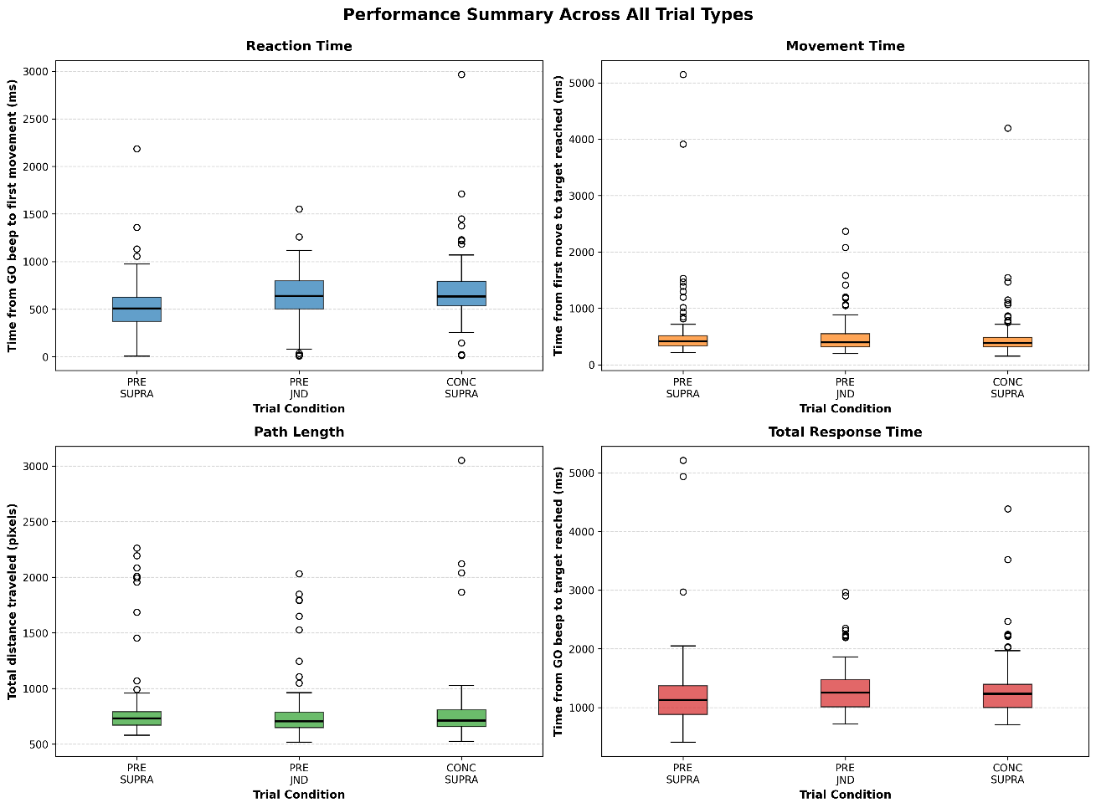
Figure 1- Reaction Time distributions across conditions
Figure 2 – Movement Duration distributions across conditions
Figure 3 – Path Length distributions across conditions

Movement Metrics and Trajectory Analysis
In addition to reaction time, movement-related metrics such as path length, movement time, and average speed were analyzed. Some participants demonstrated more direct movement trajectories and higher average speeds in pre-cued conditions compared to concurrent cue trials.
Trajectory visualizations revealed differences in movement smoothness and consistency across conditions, suggesting that cue timing may influence not only when movement is initiated but also how it is executed. These observations support the value of capturing fine-grained movement data rather than relying solely on discrete timing measures.
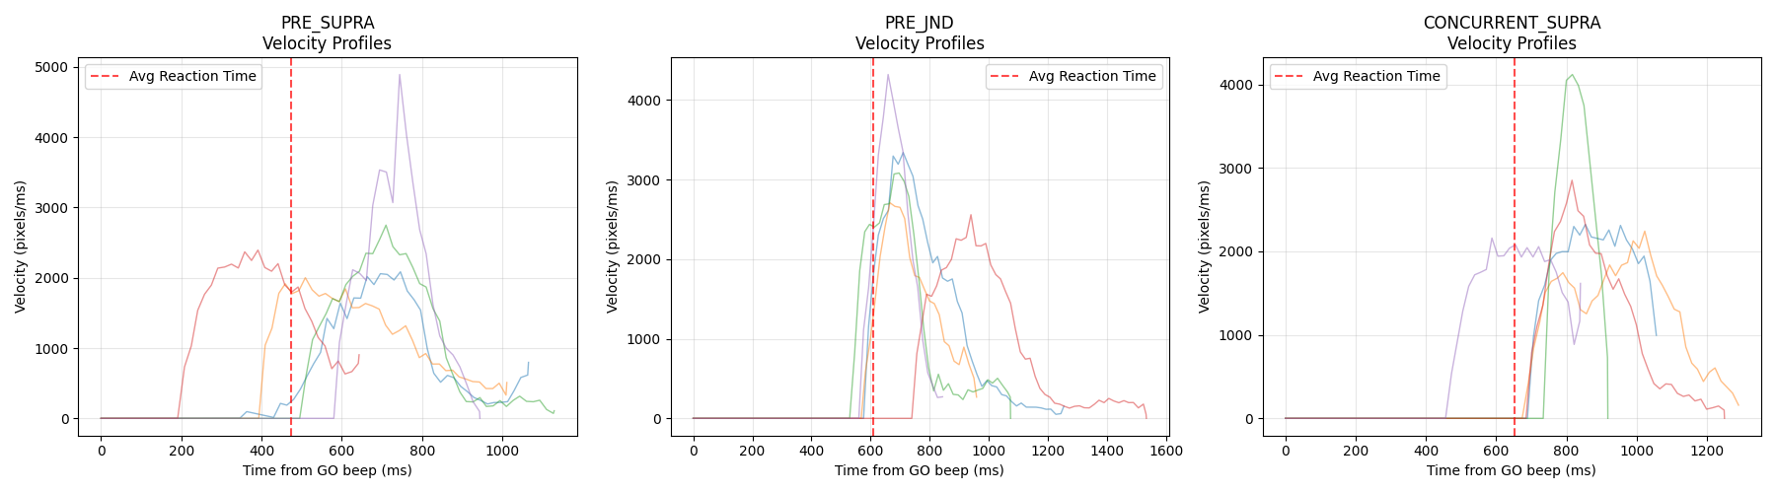
Figure 4 - velocity profiles comparison sampling
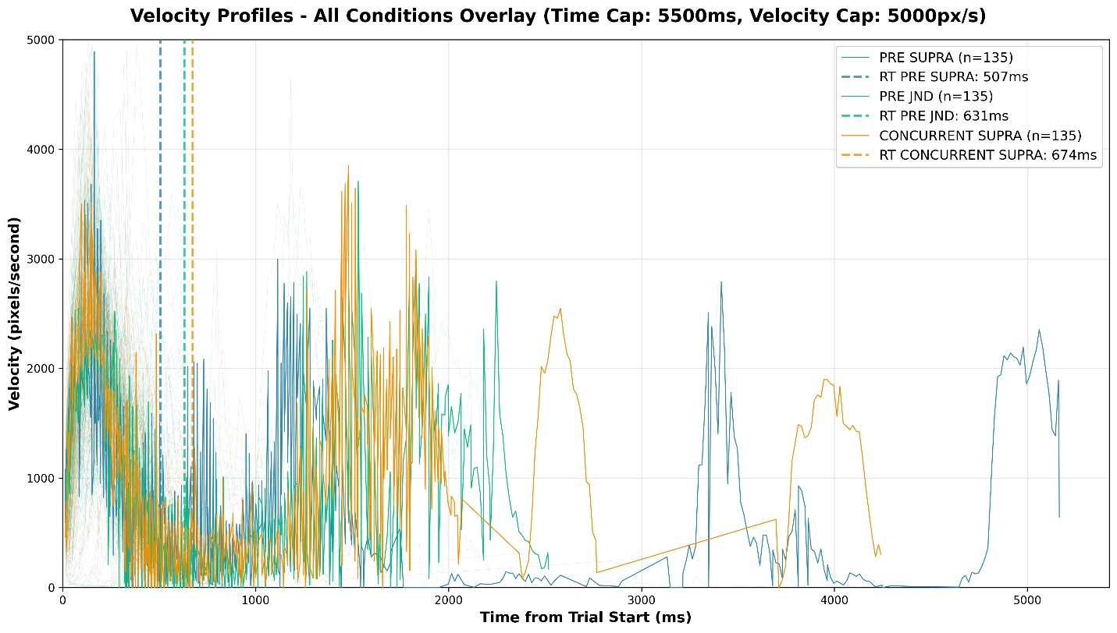
Figure 5 - velocity profiles comparison overlayed, illustrating differences in movement execution following different cue timings

Demographic and Individual Differences
In addition to condition-based comparisons, the analysis pipeline enabled exploratory segmentation of results by participant characteristics, including ADHD status and age. These analyses are presented as secondary observations and should be interpreted cautiously due to the limited sample size.
While some trends were observed, these results are not intended to support strong statistical claims. Rather, they demonstrate the system’s ability to support flexible subgroup analysis and highlight directions for future research with larger cohorts.

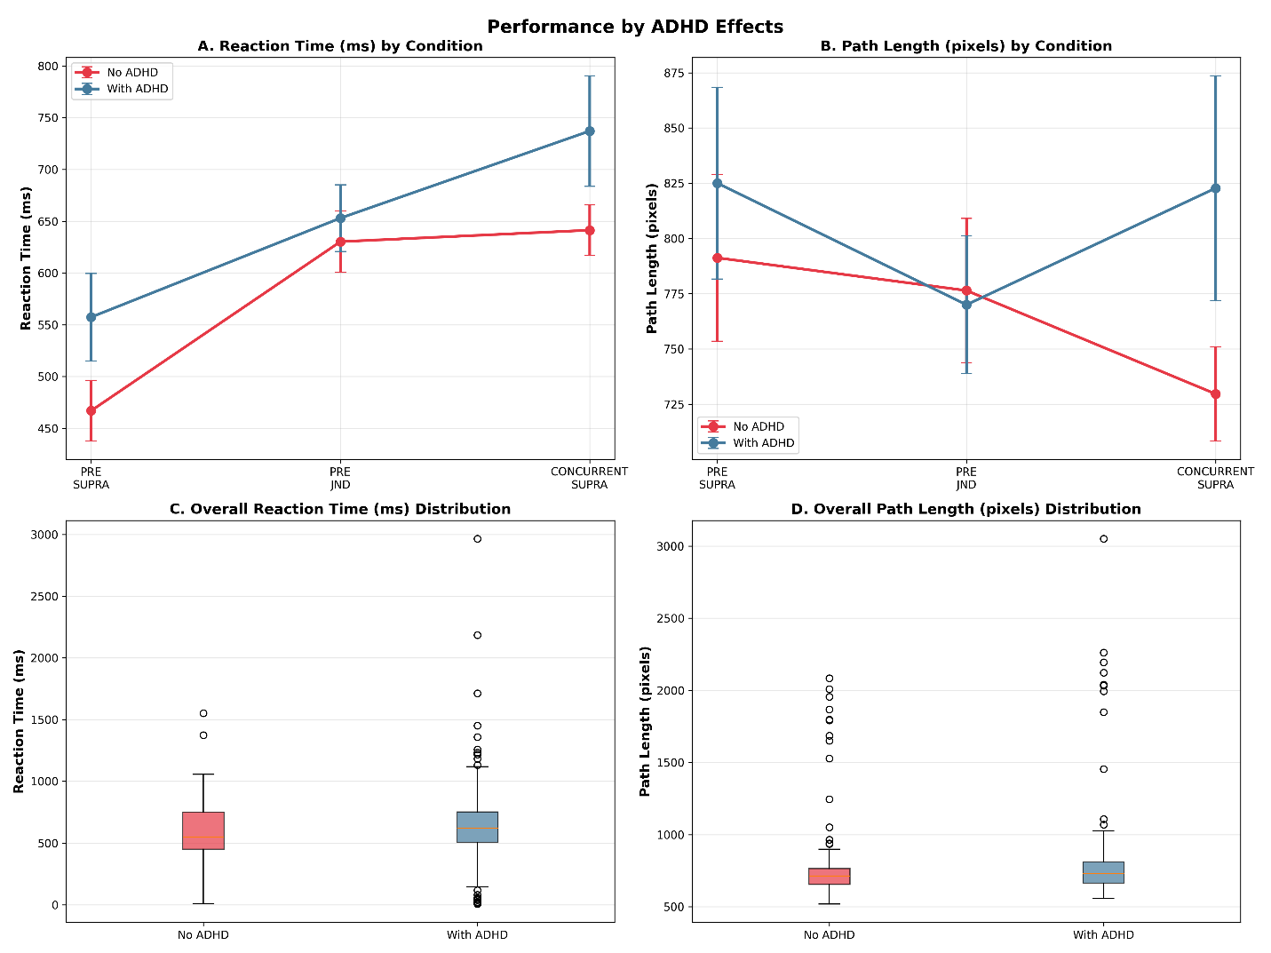
Figure 6 - illustrates reaction time differences between participants with and without self-reported ADHD

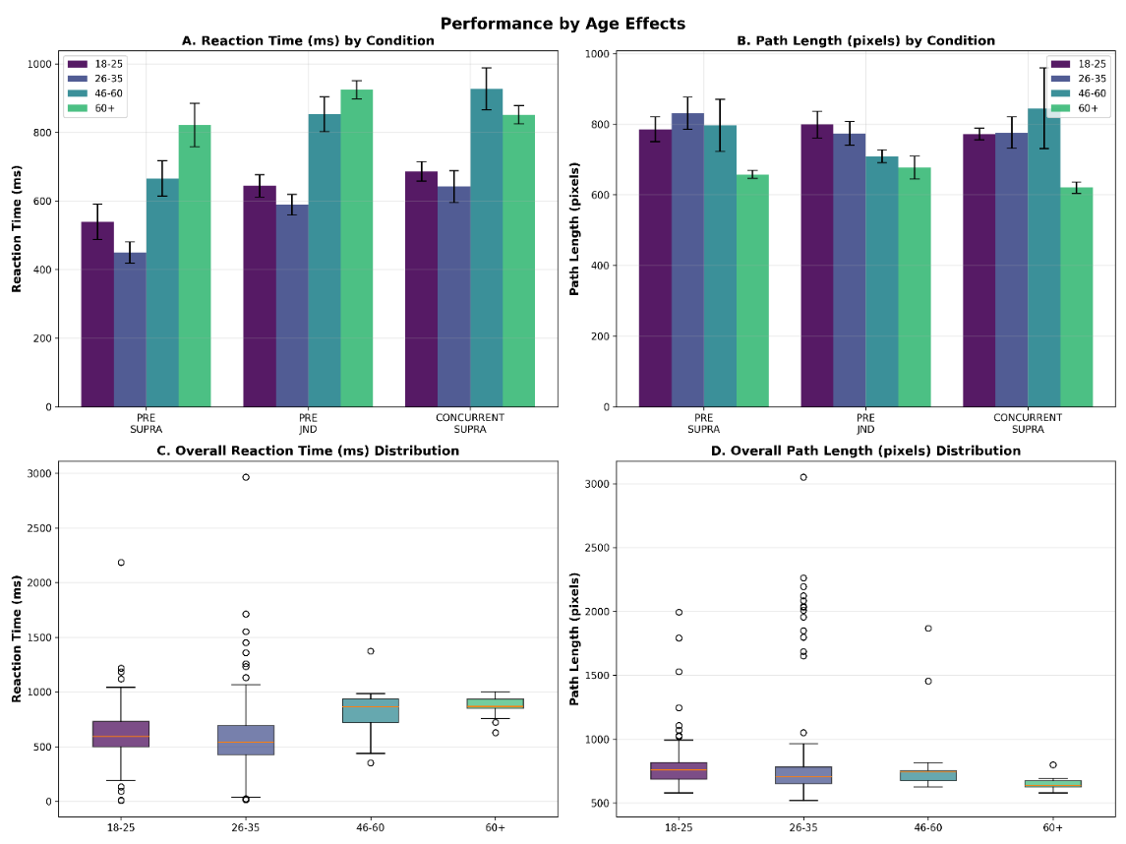
Figure 7 - presents the effect of age on selected performance metrics

Evaluation of the Experimental System
Beyond the experimental outcomes themselves, the results demonstrate the effectiveness of the developed system as a data collection platform. The system successfully guided participants through complex experimental procedures, reliably recorded high-resolution behavioral data, and supported automated analysis and visualization.
The consistency of collected data across participants indicates that the application design and workflow successfully minimized user error and experimental noise. Furthermore, the integration between mobile data collection and cloud-based analysis enabled efficient iteration and validation of results.

Limitations
Several limitations should be acknowledged when interpreting the results. The experiment was conducted using a single device model, which, while ensuring consistency, limits generalizability across different hardware configurations. Additionally, the participant sample size was constrained by practical considerations, reducing statistical power.
Environmental factors such as participant posture, hand dominance, and testing environment were not fully controlled, potentially contributing to observed variability. Finally, while the system enables precise timing and data capture, mobile platforms inherently introduce some level of latency that must be considered in fine-grained motor analyses.

Discussion Summary
Overall, the results suggest that cue timing and perceptual salience influence reaching movement behavior, with trends aligning with the proposed hypothesis. While the findings are exploratory in nature, they demonstrate the feasibility of conducting controlled motor behavior experiments using a mobile platform.
More importantly, the results validate the system as a robust and extensible experimental tool. The combination of personalized perceptual thresholding, reliable data capture, and flexible analysis provides a strong foundation for future studies with larger datasets and refined experimental designs.

Conclusion & Future Work

Conclusion
This capstone project presented the design and implementation of a complete software system for investigating the effects of subliminal and suprathreshold visual cues on reaching movement behavior. The project combined a mobile data collection application with a cloud-based storage solution and a flexible Python analysis pipeline, forming an end-to-end experimental framework.
From a software engineering perspective, the project successfully addressed challenges related to state management, data integrity, security, and usability. The Android application implemented using the Entity–Control–Boundary architectural pattern, provided a structured and maintainable foundation for managing complex experimental workflows. Local-first data persistence, combined with fault-tolerant cloud synchronization, ensured reliable data collection under real-world usage conditions.
The experimental system enabled individualized perceptual threshold determination through a JND-based procedure and supported multiple cue presentation conditions within the reaching movement task. The collected data demonstrated meaningful trends consistent with the proposed hypothesis, while also highlighting individual variability and experimental limitations.
Beyond the experimental findings themselves, the project demonstrates the feasibility of using mobile platforms for controlled behavioral research. The system’s modular design and integrated analysis tools make it suitable for reuse and extension in future studies, bridging experimental research requirements with practical software engineering solutions.

Future Work
Several directions for future development and research emerged from this project:
- Expanded Participant Pool
Conducting the experiment with a larger and more diverse participant sample would improve statistical power and enable more robust analysis of individual differences and demographic effects.
- Cross-Device Validation
Extending the application to support multiple device models and screen sizes would improve generalizability and enable broader deployment.
- Real-Time Data Monitoring
Adding real-time experiment monitoring and validation tools could help identify anomalies or inconsistencies during data collection rather than post hoc.
- Extended Experimental Paradigms
The system architecture supports the addition of new experimental conditions, alternative stimulus modalities, or different motor tasks, enabling exploration of a wider range of perceptual–motor interactions.
- Improved Automation and Reporting
Further automation of analysis and report generation, including integration with Jupyter notebooks or automated statistical summaries, could streamline future research workflows.

Final Remarks
Overall, this project provided valuable experience in designing, implementing, and evaluating a complex, real-world software system that integrates mobile development, cloud services, and data analysis. The lessons learned throughout the development process extend beyond the specific application domain and reflect core software engineering principles applicable to a wide range of projects.

Appendix A – User Guide (Android App)

A.1 Introduction
This guide provides step-by-step instructions for participants (aged 18+) utilizing the experimental application developed as part of this capstone project.
This guide is designed to provide detailed operating instructions for the research system. It focuses on describing the "nominal flow" (the standard operating procedure) of an experimental trial, with the objective of ensuring consistent and precise utilization of the research tool while maintaining the reliability and integrity of the collected data. It is intended for researchers responsible for operating the application and for laboratories specializing in the fields of neuroscience and cognitive science.

A.2 System Overview
Application Functionality: The application is a research-oriented platform designed to investigate sensorimotor integration. It performs two primary functions: first, it calibrates an individual’s perceptual threshold to establish a baseline for visual awareness. Second, it conducts experimental trials where it presents subliminal and overt cues to assess their influence on the planning and execution of goal-directed reaching movements.
Target Device: The system is specifically designed for Android-based tablets. The tablet's form factor was selected to provide a large, high-resolution workspace, which is essential for capturing natural and long-range movements. Furthermore, the device's portability facilitates conducting the experiment with many participants at any time or location.
User Interaction: Interaction with the application is entirely touch-based. The system captures high-frequency touch events as the participant performs reaching tasks on the screen. This allows for the precise recording of kinematic data, including movement initiation time, velocity profiles, and spatial accuracy, providing a detailed map of the user's motor response to visual stimuli.

A.3 Launching the Application
The application is launched by tapping the specific application icon located on the tablet's home screen.

Upon activation, the application opens directly to the initial access portal.

A.4 Login Screen
The participant of the experiment will receive the tablet from the examiner with the Login Screen already displayed. On this screen, the participant must enter a personal ID. To do so they tap the input field and enter a unique 9-digit identification number and press the “Next” button. For new participants this action will store the participant's credentials in the local database and navigate them to the Personal Details page. For returning participants the system will automatically direct the participant to the specific stage where the experiment was last interrupted. If the experiment has already been completed, a Completion Message will be displayed.
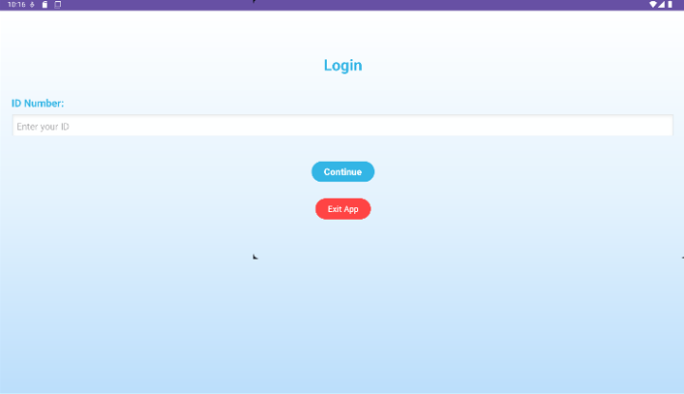

A.5 Registration Process (New Participants)
Registration is a one-time process for participants accessing the system for the first time. Upon entering a new ID on the login screen and clicking "Next," the system will detect that the user does not exist in the database and automatically redirect them to this registration page.
The participant is required to select the following details for demographic and research characterization:
- Age: Select the applicable age range.
- Gender: Select the participant's gender.
- Vision-related Information: Declare whether the participant has normal vision or utilizes vision aids (e.g., glasses/contact lenses).
- ADD/ADHD Status: Declare whether the participant has been diagnosed with attention disorders.
After completing all required fields, the participant must click the "Next" button located at the bottom of the screen. Upon submission, the system will automatically save the data and transition the user to the JND Experiment Instructions phase. If a participant fails to select all required fields or leaves some options blank, a notification will appear informing them that the form is incomplete and must be finalized before proceeding.

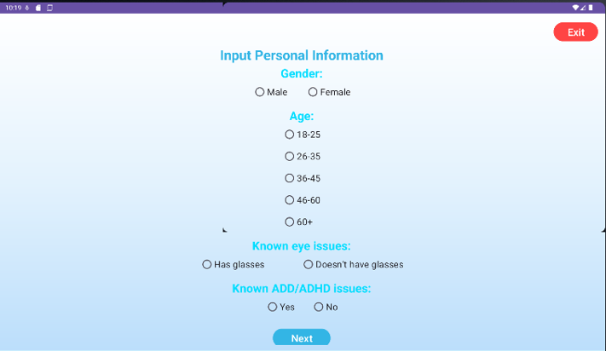

The participant can leave the page at any time, but the data will be discarded and they will have to register from the start if they wish to take part of the experiment.
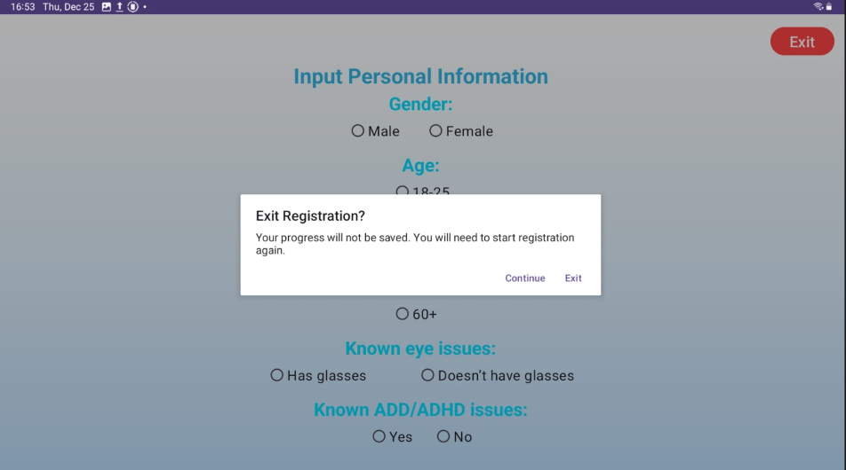

A.6 Perceptual Threshold (JND) Task

A.6.1 Explanation Screen
The purpose of this screen is to prepare the participant for the initial visual calibration task, which is designed to determine their specific sensitivity to blue color differences (Just Noticeable Difference).
The participant is presented with the following guidelines:
- Task Objective: On the following page, the participant must select the lighter color between two options - A or B.
- Visual Elements: The interface will display four squares (two blue and two gray); the participant must ignore the gray squares and focus exclusively on the blue ones.
- Trial Volume: The test consists of 100 trials in total.
- Initiating the Task: To begin, the participant must tap anywhere on the screen.
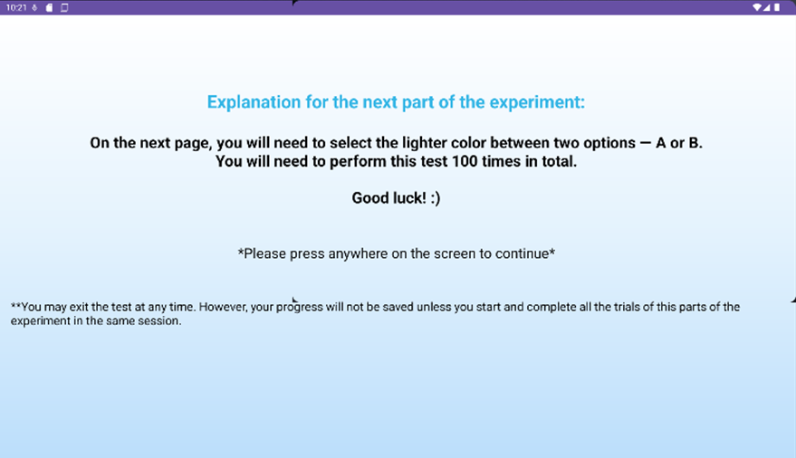

A.6.2 Performing the JND Task
- Participant View: The screen displays four squares positioned in the center. The participant’s task is to identify which of the two blue squares is brighter. A progress indicator is located at the top of the screen, displaying the current trial number (e.g., "Trial 1 of 100").
- Response Method: The participant must respond by tapping directly on the blue square they perceive to be the brightest of the two.
- Number of Trials: The task consists of 100 consecutive trials.
- Task Completion: Upon completing all 100 trials, a "Next" button will appear on the screen. Pressing this button will automatically navigate the participant to an additional explanation screen regarding the next phase of the experiment.
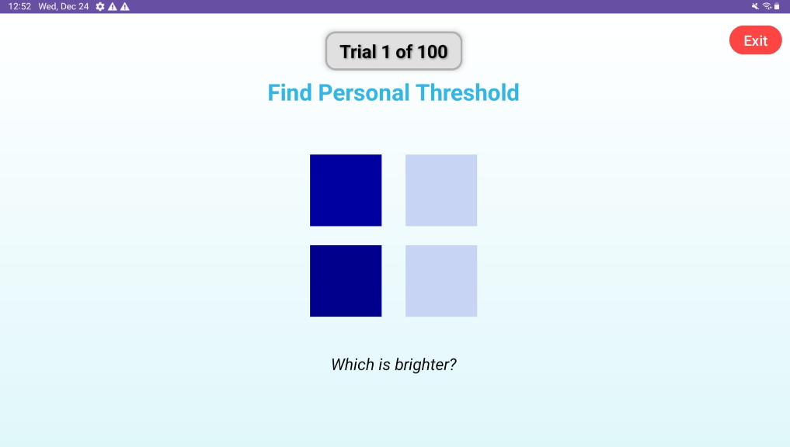

The participant may exit the test at any time; however, progress of this part of the experiment will not be saved unless all trials are completed within the same session.
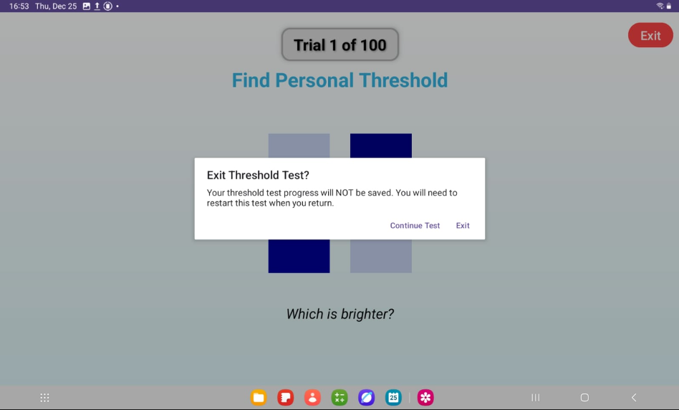

A.7 Reaching Movement Experiment

A.7.1 Explanation Screen
The purpose of this task is to prepare the participant for the primary experimental task, which evaluates motor movement toward a target in response to auditory cues and visual stimuli.
The participant is presented with the following guidelines:
- Auditory Cues: On the following page, three beeps of the same tone will be played.
- Movement Initiation: Upon the fourth beep, which will be in a different tone, the participant must move their finger from the center of the board (marked with an "X") toward the target.
- Target Selection: There are four targets, the participant must select the one displaying an obvious color difference.
- Obstacles and Speed: It is critical to avoid the black square obstacles on the way to the target and to complete the movement as quickly as possible.
- Trial Volume: The test consists of 15 trials in total.
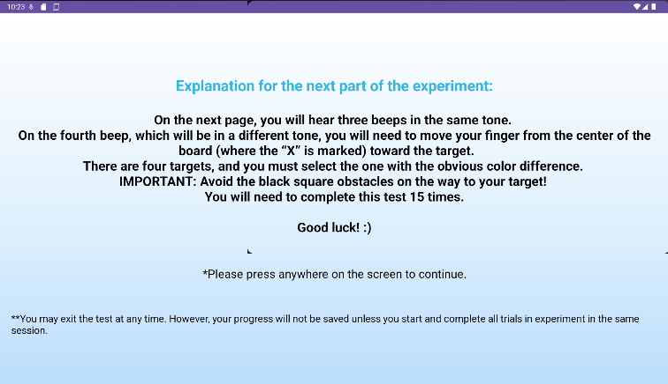
Throughout the duration of the experiment, members of the research team are present alongside the participants. If any instructions remain unclear, the participant is encouraged to ask questions and consult with the team at any stage.

A.7.2 Practice Trial
The purpose of the practice trial is to allow the participant to experience the dragging mechanism, familiarize themselves with the auditory cues, and practice navigating around obstacles, without recording the data for research purposes.
The participant performs a single trial to practice the task according to the instructions previously provided.
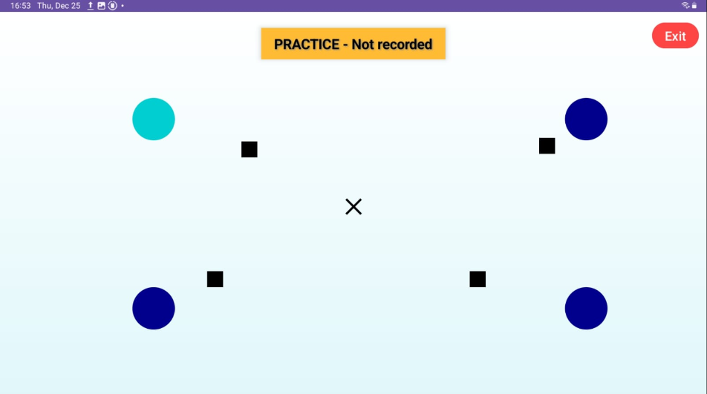

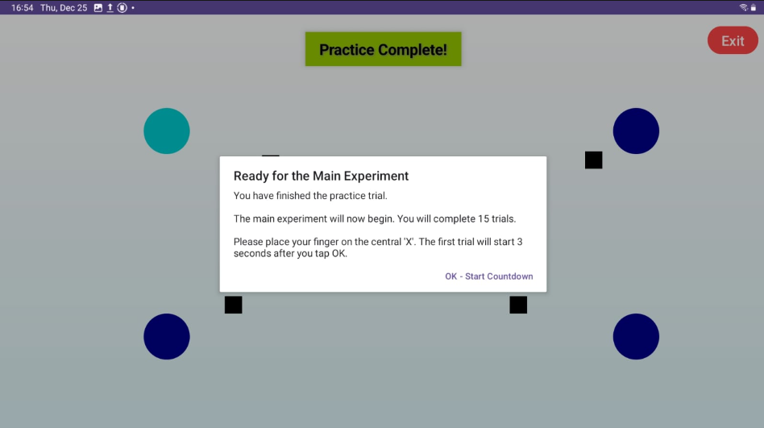

A.7.3 Experimental Trials
The actual test consists of 15 consecutive trials. In each trial, the participant waits for the sequence of auditory cues. Upon the fourth beep, a color cue appears and one of the targets changes its visual properties.
What the participant is expected to do in each trial:
- Identify the Target: Rapidly identify the target displaying a different color from the other three.
- Execute Movement: Perform a fast and accurate dragging motion from the center "X" to the target while navigating around the black square obstacles.
- Complete the Set: Continue until all 15 trials are completed and the final action button is displayed.

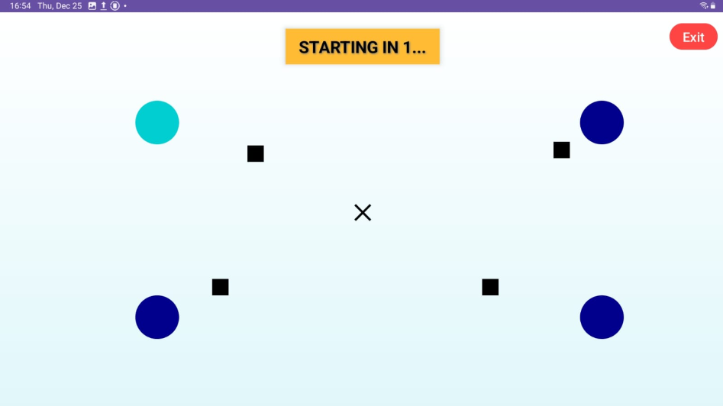

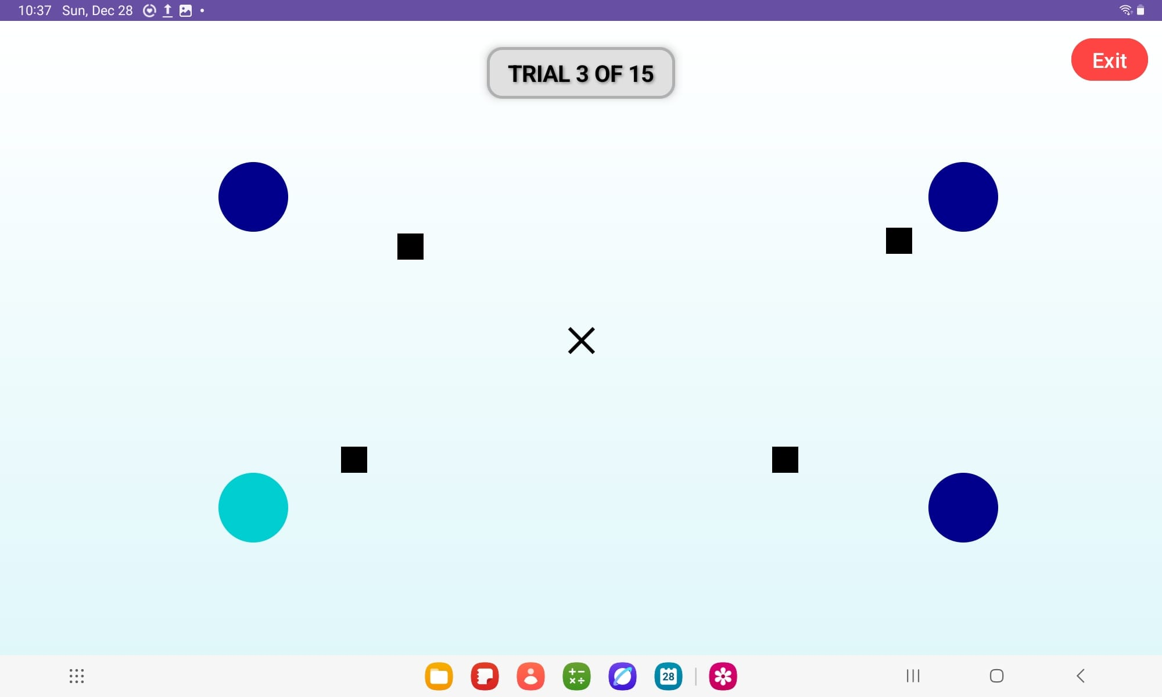

If the participant attempts to exit the task before completing all 100 trials, a warning message will be displayed. This notification informs the participant that their progress will not be saved and that all data for this part of the experiment, from the current session, will be deleted unless the entire set of trials is completed.
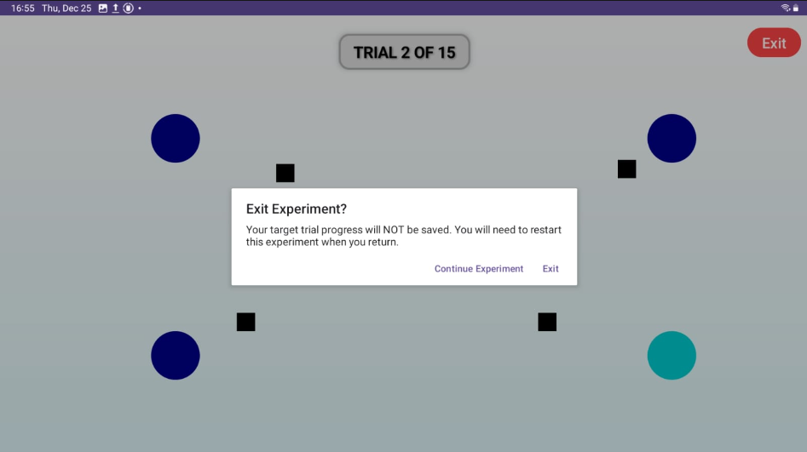

After successfully completing all 15 trials, a "Finish" button will appear on the screen. Clicking this button will transition the participant to the final experiment summary or exit screen.

A.8 Experiment Completion
Upon successful completion of all tasks, the system displays a summary message to the participant, confirming the successful conclusion of the experiment. The appearance of this screen serves as official confirmation for the participant that all experimental data (including the JND task and the Reaching Movement task) have been saved in the system and uploaded to the online database and that their participation has ended. At the end of the experiment, the participant must return the tablet to the examiner.
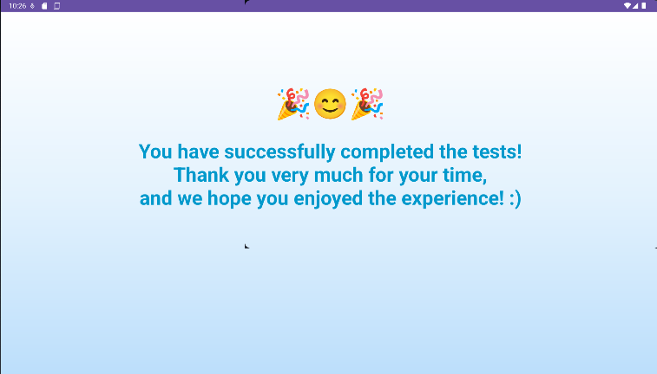

Appendix B – User Guide (Web Interface)

B.1 Introduction
This guide provides step-by-step instructions for researchers utilizing the web-based data analysis interface developed as part of this capstone project.
The web interface provides an accessible, graphical alternative to command-line analysis tools. It enables researchers to perform comprehensive statistical analysis, generate visualizations, and export experimental data through an intuitive browser-based application. This guide describes the standard procedures for launching and using the web interface to analyze experimental data collected from the Android application.

B.2 System Overview
Interface Purpose: The web interface provides visual access to the data analysis pipeline, including statistical testing, velocity profile generation, demographic comparisons, and data export capabilities.
User Requirements: The interface requires a Windows computer with an active internet connection for initial setup. All experimental data is accessed directly from the Firebase cloud database.
User Interaction: All operations are performed through standard web browser interactions - clicking buttons, selecting options from dropdown menus, and downloading generated files.

B.3 Launching the Web Interface

B.3.1 First-Time Launch
The web interface is launched using the automated setup script provided with the system.
- Navigate to the project folder on your computer.
- Locate and double-click the file named Setup_And_Launch.bat
- A black terminal window will open displaying the setup progress.
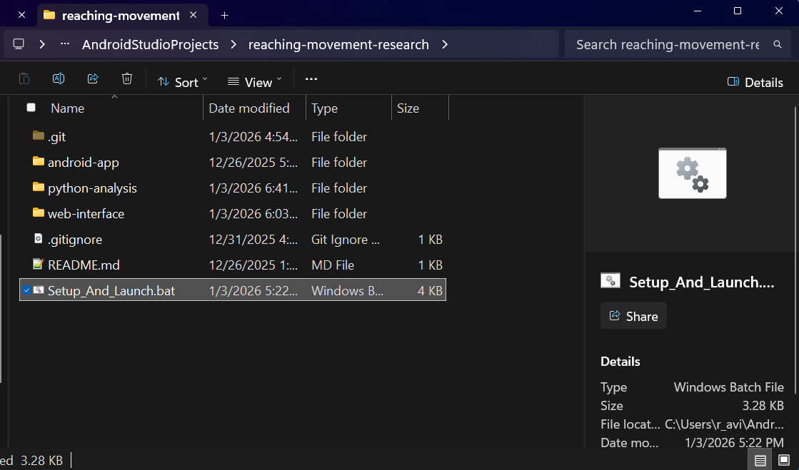
- The script will automatically:
  - Verify required software is installed
  - Configure the analysis environment
  - Start the backend server
  - Start the web interface
- After approximately 10-15 seconds, your web browser will automatically open to the interface.
Note: The first time you run the script, it may take 2-3 minutes to complete initial setup. Subsequent launches will be much faster.
During operation, two terminal windows will remain open in the background. These windows must stay open while you use the interface. You may minimize them, but do NOT close them.

B.3.2 Subsequent Launches
For all future sessions, simply repeat the same process:
- Double-click Setup_And_Launch.bat
- Wait for the browser to open automatically
- Begin your analysis work
The interface will remember your theme preference (light or dark mode) from previous sessions.

B.4 Interface Layout
Upon successful launch, the web interface displays a sidebar-based layout with distinct functional areas.
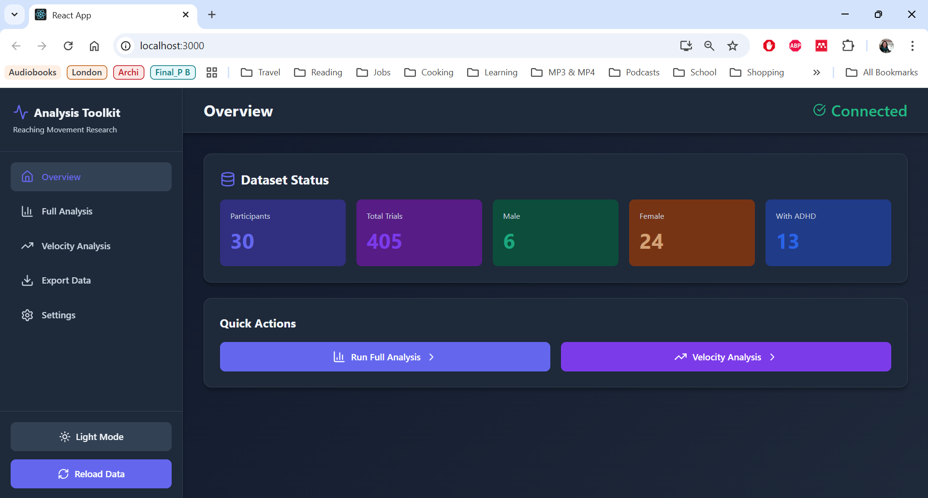The interface consists of three main areas:

B.4.1 Sidebar Navigation (Left)
The sidebar provides access to all interface functions:
- Overview -- Dashboard showing dataset statistics
- Full Analysis -- Generate comprehensive statistical analysis and plots
- Velocity Analysis -- Create specialized velocity profile visualizations
- Export Data -- Download raw and processed data files
- Settings -- Database management tools
At the bottom of the sidebar are two control buttons:
- Theme Toggle -- Switch between light and dark display modes
- Reload Data -- Refresh database statistics after new data collection
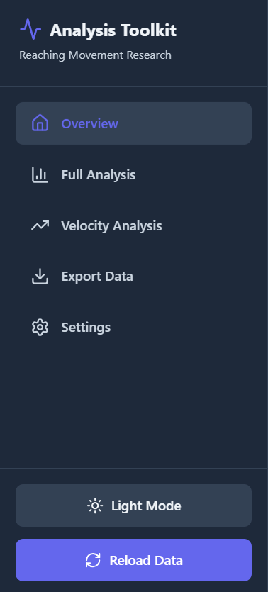

B.4.2 Header (Top)
The header displays the current page title and a connection status indicator. A green checkmark with "Connected" confirms the system is ready to use.


B.4.3 Main Content Area (Center)
The main area displays information and controls specific to the selected page. This area is scrollable for pages with multiple sections or large visualizations.

B.5 Overview Page
The Overview page is displayed automatically when the interface opens. It provides a summary of your experimental dataset and quick access to analysis functions.
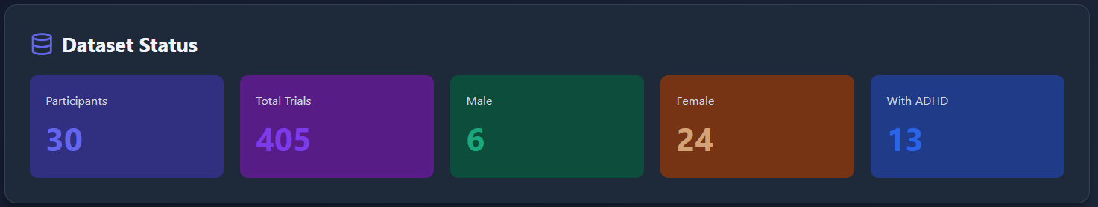

B.5.1 Dataset Statistics
The page displays five key statistics about your data:
- Participants -- Total number of unique participants
- Total Trials -- Complete count of all experimental trials
- Male -- Number of male participants
- Female -- Number of female participants
- With ADHD -- Number of participants with attention deficit diagnoses
Each statistic appears in a colored card with a large number for easy reading.

B.5.2 Quick Actions
Below the statistics are two buttons that navigate directly to analysis functions:
- Run Full Analysis -- Opens the comprehensive analysis page
- Velocity Analysis -- Opens the velocity plot configuration page
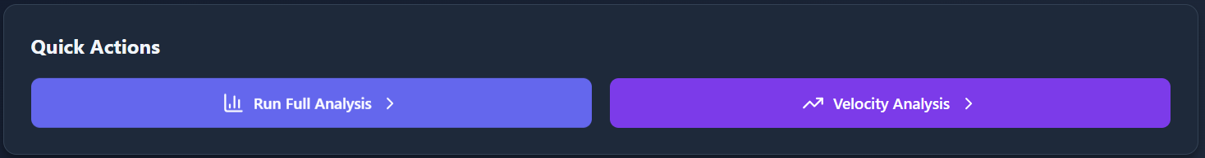

B.6 Running Full Analysis
The Full Analysis function generates a complete statistical report with all standard visualizations.

B.6.1 Starting the Analysis
- Click Full Analysis in the sidebar navigation.
- The page displays a description of what will be generated.
- Click the Start Analysis button.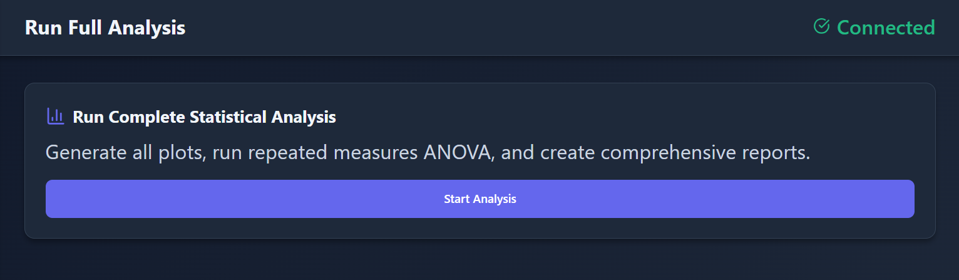
- The button text changes to "Analyzing..." and the analysis begins. Wait for the analysis to be completed. This typically takes 10-30 seconds depending on dataset size.
- A notification will appear confirming the analysis is complete, and the page will automatically display the results.

B.6.2 Viewing Results
After completion, the Results page displays three types of content:
Success Notification: A green banner appears at the top confirming the analysis completed successfully.
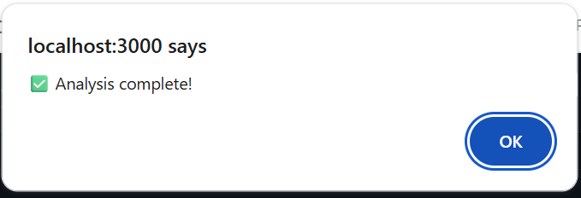
Statistical Report: A text box displays the detailed statistical report, including sample sizes, ANOVA results, effect sizes, and post-hoc comparisons.
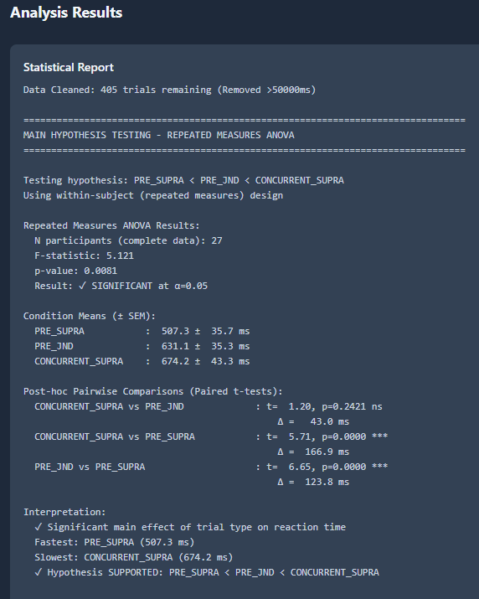
Visualizations: Below the report, all generated plots are displayed:
- Performance Summary -- Overall performance across all conditions
- Demographic Comparisons -- Separate plots comparing performance by gender, ADHD status, and vision correction
Scroll down to view all generated visualizations.

B.6.3 Downloading Results
To save all results to your computer:
- Click the Download All (ZIP) button at the top of the results page. 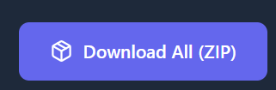
- Your browser will download a ZIP file containing:
  - All plot images (PNG format)
  - Statistical report (text file)
  - Timestamped filename for easy organization
- The file will appear in your browser's default download location (usually the Downloads folder) unless told otherwise.
You may now extract the ZIP file and use the images and report in presentations, papers, or further analysis.

B.7 Generating Velocity Plots
The Velocity Analysis function creates specialized plots showing movement velocity profiles over time.

B.7.1 Configuring Settings
- Click Velocity Analysis in the sidebar navigation.
- The page displays four configurable settings:
Time Cap (ms): Enter the maximum time to display on the horizontal axis. The default value of 5500 milliseconds shows the full movement period.
Velocity Cap (px/s): Enter the maximum velocity to display on the vertical axis. The default value of 5000 pixels per second accommodates typical reaching movements.
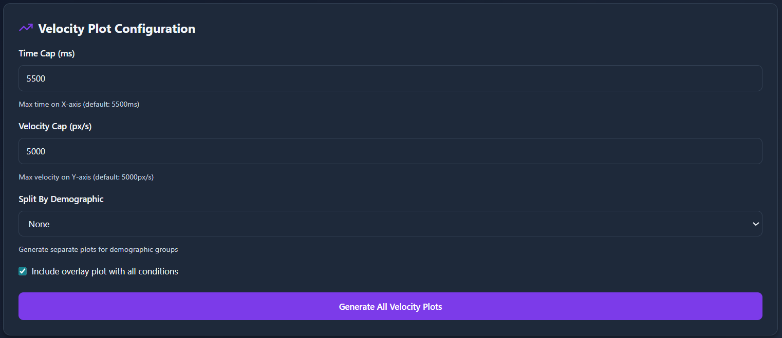
Split By Demographic: Use the dropdown menu to optionally generate separate plots for different participant groups:
- None (single plot for all participants)
- ADHD (separate plots for participants with/without attention deficit)
- Gender (separate plots for male/female participants)
- Glasses (separate plots for participants with/without vision correction)
Include Overlay Plot: Check this box to generate an additional plot showing all experimental conditions on a single graph for easy comparison. This option is enabled by default.
- Adjust any settings as needed for your analysis or leave the default values.

B.7.2 Generating Plots
- Click the Generate All Velocity Plots button.
- The button text changes to "Generating..." while the plots are created.
- Wait for completion (typically 5-15 seconds).
- A notification confirms the plots were generated successfully, and the page automatically displays the results.

B.7.3 Viewing Velocity Results
The Velocity Results page displays all generated plots in a vertical layout.
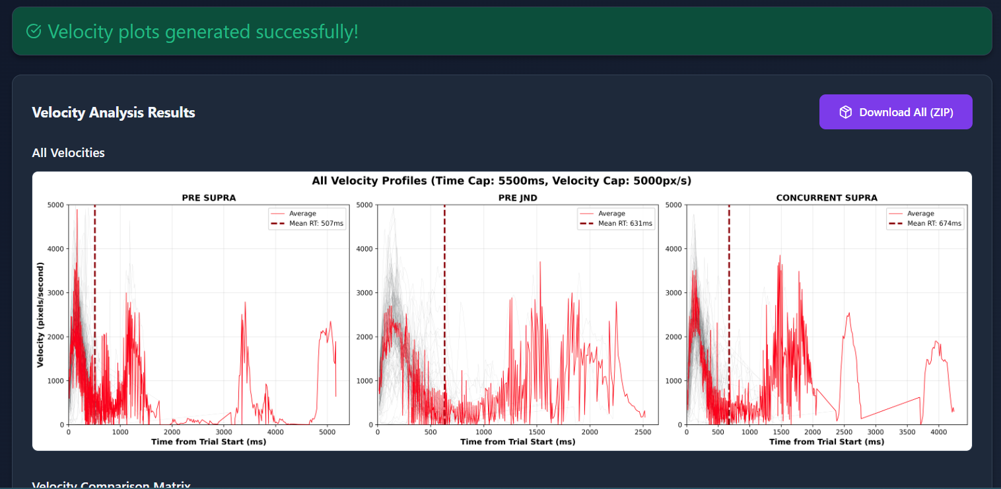Each plot includes:
- A descriptive title indicating the condition or demographic group
- A line graph showing velocity changes over time
- Multiple colored lines representing different experimental conditions
If you selected a demographic split, separate plots will appear for each group, clearly labeled with titles.
If the overlay option was enabled, you will also see a combined plot with all conditions displayed together.
Scroll down to view all generated plots.

B.7.4 Downloading Velocity Results
- Click the Download All (ZIP) button at the top of the results page.
- A ZIP file containing all velocity plots will be downloaded to your computer.
- The filename includes a timestamp for easy organization.

B.8 Exporting Data
The Export Data page provides direct access to download experimental data in spreadsheet format.
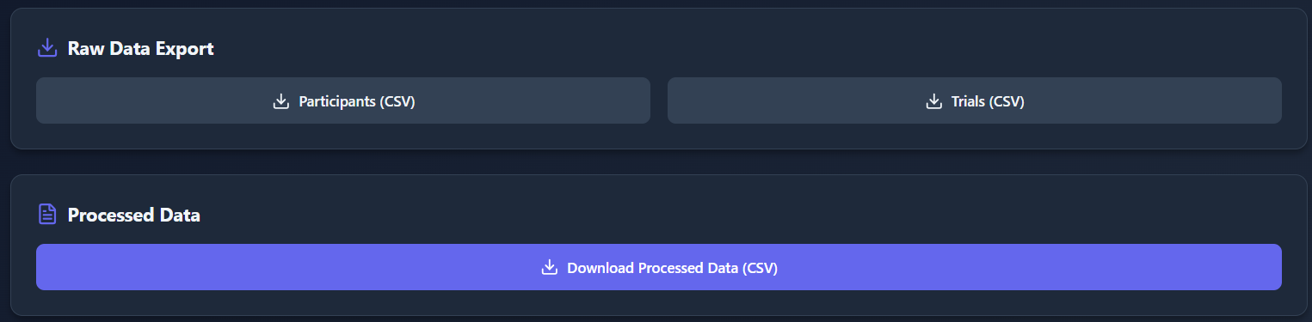

B.8.1 Raw Data Export
The first section offers two downloads:
- Participants (CSV) -- Downloads participant information including demographics
- Trials (CSV) -- Downloads individual trial records including movement data and performance metrics
Click either button to immediately download the corresponding CSV file. These files open in Excel, Google Sheets, or any spreadsheet application.

B.8.2 Processed Data Export
The second section provides access to the cleaned and computed dataset used in statistical analyses:
Download Processed Data (CSV) -- Downloads the complete dataset with all computed metrics (curvature, velocity profiles, reaction times, etc.)
This export is useful for performing custom analyses in external statistics software or sharing data with collaborators.
All downloaded files include timestamps in their filenames to help you organize multiple exports.
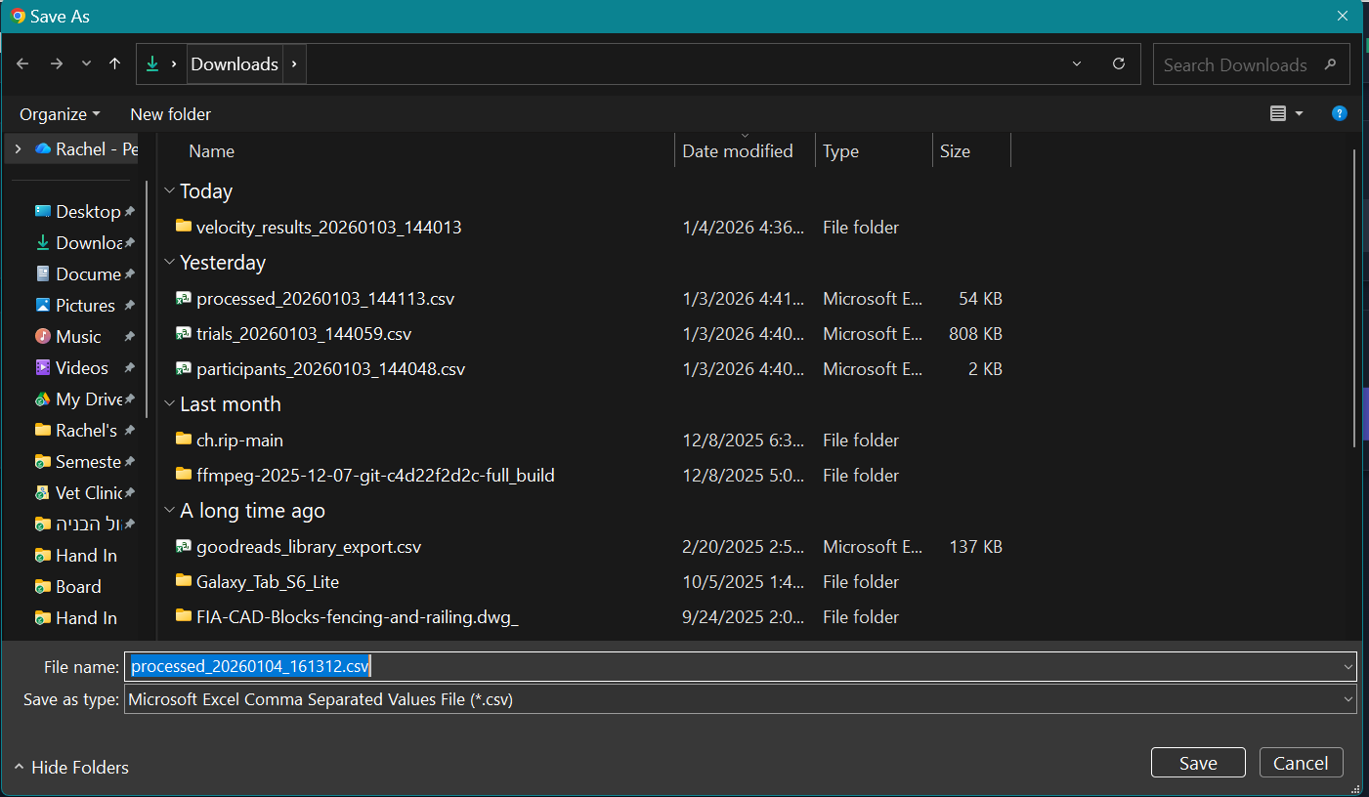

B.9 Settings
The Settings page provides tools for database management and system information.
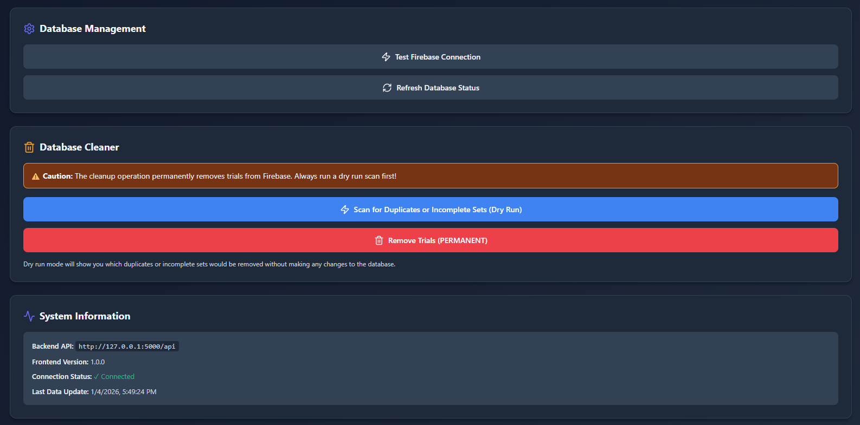

B.9.1 Database Management
The first section contains two functions:
Test Firebase Connection: Click this button to verify the system can communicate with the cloud database. A notification will confirm the connection is working.
Refresh Database Status: Click this button to update the participant and trial counts displayed on the Overview page. Use this after new data has been collected and uploaded to ensure statistics are current.

B.9.2 Database Cleaner
The second section provides tools for maintaining data quality by identifying and removing duplicate or incomplete trial records.
Important: A yellow warning banner reminds users that cleanup operations permanently delete records from the database.
The cleaner works in two steps:
Step 1: Scan for Issues (Safe)
Click the blue Scan for Duplicates or Incomplete Sets (Dry Run) button. This identifies problematic records without making any changes.
After scanning, the interface displays the results:
- Number of duplicate trials found
- Number of incomplete trial sets found
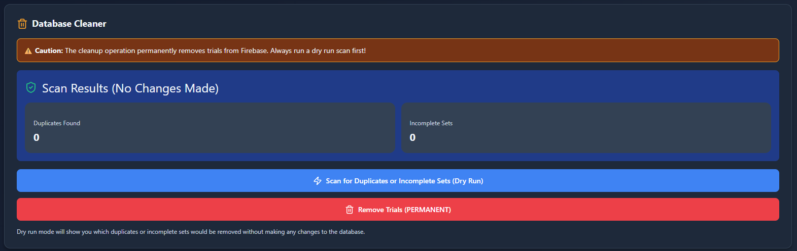
Vs
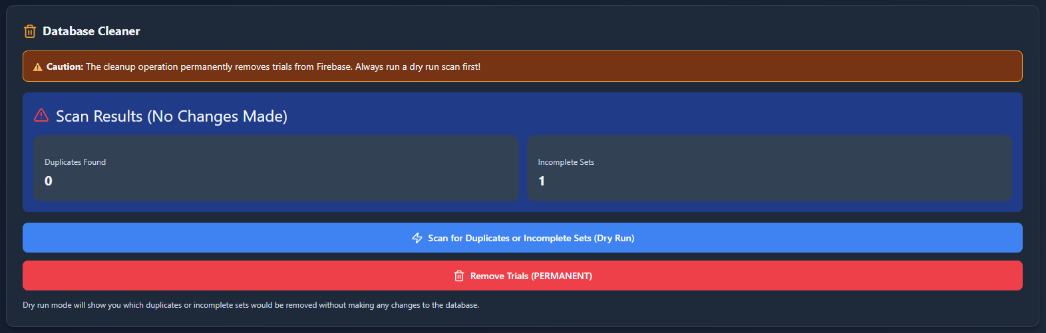

Step 2: Remove Issues (If Needed)
Only if the scan reveals problems and you wish to remove them:
- Click the red Remove Trials (PERMANENT) button.
- A confirmation dialog appears asking you to confirm the deletion.
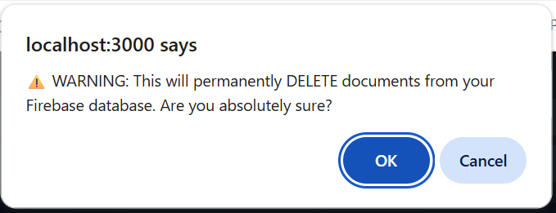
- Click "Okay" only if you are certain you want to proceed.
- Wait for the operation to complete.
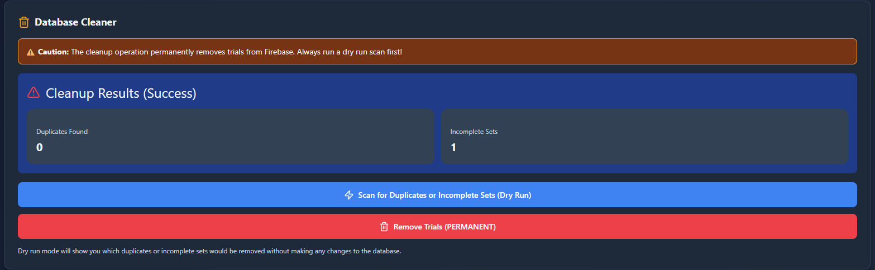
- Return to the Overview page to see updated statistics.
Note: Database cleanup should only be performed when necessary and after consulting with the research team. Always run a scan first to understand what will be deleted.

B.9.3 System Information
The third section displays technical details about your installation:
- Backend API address
- Frontend version number
- Current connection status
- Timestamp of last data update
This information is primarily for technical support purposes.

B.10 Reload Data
The Reload Data button is located at the bottom of the sidebar and can be accessed from any page.
Click this button to refresh the database connection and update all statistics. Use this function:
- After new experimental data has been collected
- After performing database cleanup
- When statistics appear outdated
The button displays "Reloading..." while updating, and a notification confirms when the update is complete.

B.11 Switching Display Modes
The interface supports two visual themes:
- Light Mode -- Bright interface with blue accents (default)
- Dark Mode -- Dark background for reduced eye strain during extended sessions
To switch themes:
- Click the theme toggle button at the bottom of the sidebar (displays moon icon for dark mode or sun icon for light mode).

- The interface immediately changes to the selected theme.
Your preference is automatically remembered for future sessions.

B.12 Closing the Interface
When you have finished your analysis session:
- Close the web browser window or tab.
- Locate the two terminal windows that opened when you launched the interface (they may be minimized in your taskbar).
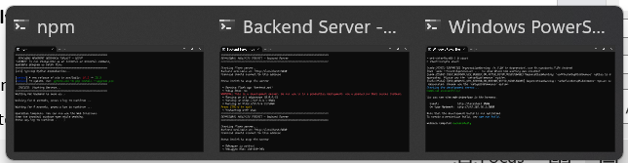
- Close both terminal windows by clicking the X button on each window.
The interface is now completely shut down. To use it again, simply double-click Setup_And_Launch.bat as described in Section B.3.

B.13 Typical Analysis Workflow
For a standard analysis session, researchers typically follow this workflow:
- Double-click Setup_And_Launch.bat to launch the interface
- Wait for the browser to open automatically
- Review the Overview page to verify dataset statistics
- Navigate to Full Analysis and click Start Analysis
- Wait for results to generate
- Review the statistical report and visualizations
- Click Download All (ZIP) to save the complete analysis package
- Navigate to Velocity Analysis (if needed for your research)
- Configure velocity plot settings
- Click Generate All Velocity Plots
- Review velocity visualizations
- Click Download All (ZIP) to save velocity plots
- Navigate to Export Data (if needed)
- Download any required data files
- Close the browser and terminal windows

B.14 Notes for Users
- Keep Terminal Windows Open: The two terminal windows that appear during launch must remain open while you use the interface. Closing them will stop the system.
- Download Results Immediately: Results are not saved automatically between sessions. Always download analysis results before closing the interface.
- One Analysis at a Time: Wait for each analysis to complete before starting another. The interface will show "Analyzing..." or "Generating..." while processing.
- Network Requirement: The interface requires internet connectivity to access the Firebase database. Ensure you have an active connection before launching.
- Automatic Browser Opening: The script automatically opens your default web browser. If the browser does not open, manually navigate to: http://localhost:3000
This web interface provides researchers with an accessible way to analyze experimental data without requiring programming experience. All analysis functions utilize validated statistical methods consistent with the research objectives of the capstone project.

Appendix C – Maintenance Guide

C.1 Introduction
This maintenance guide is intended to support the continued use, maintenance, and extension of the system developed as part of the Capstone project. The guide is aimed at future developers, project supervisors, and researchers who may wish to adapt or extend the system beyond its original scope.
The document focuses on system-specific technical aspects, including installation prerequisites, configuration of external services, code organization, and maintenance considerations. It does not attempt to provide general tutorials for development tools or third-party platforms but rather documents the components and decisions unique to this project to facilitate long-term usability and knowledge transfer.

C.2 System Environments

C.2.1 Hardware Requirements
- Supported device type (Android tablet)
- Recommended Screen Size: 10.4 inches (measured diagonally)
- Recommended Resolution: 2000 x 1200 pixels
- Input method (touch screen)
- Network connectivity requirements (for data upload)

C.2.2 Software Environment
Android Application Environment
The mobile application was developed for the Android platform and requires the following software environment for maintenance and further development:
- Operating System:
Android OS (minimum SDK level 24, target SDK level 34)
- Development Environment:
Android Studio (recommended for building and deploying the application)
- Programming Language:
Kotlin (JVM target 1.8)
- Build System:
Gradle (Android Gradle Plugin)
The application uses standard Android libraries for UI, lifecycle management, and background processing, as well as Google Firebase services for analytics and cloud data storage.

Data Analysis Environment
The data analysis pipeline was implemented in Python and is intended to run in a desktop development environment.
- Python Version:
Python 3.13 (or compatible Python 3.x version)
- Recommended Tools:
  - Visual Studio Code (VS Code)
  - Jupyter Notebook (optional, for interactive analysis)
- Package Management:
Python packages are installed using pip based on a provided requirements.txt file.

Web Interface Environment
In addition to the command-line analysis tools, the system includes a web-based interface implemented using modern web technologies.
Backend:
- Python 3.13
- Flask (REST API)
- Matplotlib (non-interactive backend for server-side rendering)
Frontend:
- Node.js (LTS recommended)
- React (via Create React App)
- Browser-based execution (no installation required for end users)
The web interface communicates exclusively with the Python backend API and does not access experimental data directly.

C.3 Installation Instructions

C.3.1 Android Application Installation
To install and maintain the Android application:
- Open the project in Android Studio.
- Ensure that the Android SDK corresponding to the target SDK version is installed.
- Verify that required Gradle dependencies are resolved automatically.
- Build the application using the standard Gradle build process.
- Generate a signed APK for deployment on the target device.
- Install the APK on the tablet via USB or Android Debug Bridge (ADB).
The application uses Firebase services and therefore requires appropriate project configuration files to be present prior to building.

C.3.2 Python Analysis Tools Installation
The Python-based analysis tools are installed using a standard Python virtual environment.
- Create and activate a Python virtual environment.
- Install required dependencies using the provided requirements.txt file.
- Verify successful installation by running the connectivity or test scripts.

Python Dependency Categories
The analysis environment relies on the following categories of Python libraries:
- Cloud Connectivity:
Firebase Admin SDK for accessing Firestore data.
- Data Manipulation:
Libraries for structured data handling and numerical computation.
- Visualization:
Libraries for generating plots and interactive visualizations.
- Statistical Analysis:
Libraries for computing descriptive and inferential statistics.
- Optional Tools:
Libraries supporting interactive analysis, API extensions, and data export.
This modular dependency structure enables selective extension of the analysis pipeline without modifying the core system.
In addition to the command-line analysis workflow, the Python environment also supports a backend server used by the web interface.
After installing dependencies:
- The analysis tools may be executed via scripts (for batch or research use), or
- A local Flask server may be launched to serve analysis results to the React frontend.
Both execution paths rely on the same underlying analysis modules and data access logic.

C.4 Configuration and External Services
This section describes the external services used by the system and the configuration required to maintain and deploy the application. The focus is on system-specific configuration relevant to continued use and extension of the project.

C.4.1 Firebase Configuration
The system uses Google Firebase as its primary external service for cloud-based data storage and experiment data synchronization. The following Firebase services are required:
- Cloud Firestore – used for storing participant metadata and trial-level experimental results.
- Firebase App Check – used to verify that data access requests originate from a trusted application instance.
A Firebase project must be created and linked to the Android application to enable these services. The Android application requires the appropriate Firebase configuration file to be present in the project during the build process.
Firestore data is organized using a participant-centric structure, where each participant is represented by a unique document and trial data is stored as a subcollection. This structure is expected by the analysis pipeline and should be preserved to ensure compatibility.

C.4.2 Security Configuration
Protecting experimental data and preventing unauthorized access are essential aspects of system maintenance. Several security mechanisms are employed within the system.
Application Verification
Firebase App Check is used to validate application instances before allowing access to cloud resources. The system supports different App Check providers for development and production environments:
- Production Environment:
A device integrity provider is used to verify that requests originate from a trusted physical device.
- Development Environment:
A debug provider may be enabled to allow testing on emulators or development devices.
Maintainers should ensure that the appropriate provider is enabled based on the deployment context.

Credential Management
Sensitive configuration files and credentials are excluded from version control. These include service account keys and Firebase configuration files. A strict .gitignore policy is used to prevent accidental exposure of sensitive data.
If credentials are compromised or need to be rotated, new keys should be generated and existing keys revoked immediately. The system does not require hard-coded credentials within the application code.

C.4.3 Application Signing and Deployment
The Android application is distributed as a signed APK to ensure application integrity and prevent unauthorized modification.
Maintainers are required to:
- Generate or maintain a secure signing key.
- Configure the build system to use the signing key for release builds.
- Distribute only signed application builds to participant devices.
Unsigned or debug builds should not be used for data collection, as they may bypass security mechanisms or introduce inconsistencies.

C.4.4 Version Control Configuration
The project is maintained in a single version control repository containing both the Android application and the Python analysis tools. Proper repository configuration is essential for long-term maintenance.
Key practices include:
- Excluding sensitive files and generated artifacts using .gitignore.
- Maintaining a clear directory structure separating application and analysis components.
- Using consistent commit practices to track changes across system components.
These practices support reproducibility, security, and collaborative maintenance.

C.5 System Structure and Code Organization

C.5.1 Android Application Structure
The Android application is organized according to the Entity–Control–Boundary (ECB) architectural pattern. This structure separates user interface components, application logic, and data representation, improving maintainability and extensibility.
The main packages are organized as follows:
- Boundary
Contains Android Activities and ViewModels responsible for user interaction, screen navigation, and presentation of experimental instructions and tasks.
- Control
Contains controller and helper classes responsible for managing experiment flow, trial sequencing, background processing, and coordination between the user interface and data layer.
- Entity
Contains data model classes and data access objects (DAOs) used for local data persistence. This includes participant records, trial results, and database configuration.
In addition to these packages, the application includes an application-level initialization component responsible for configuring global resources during startup.
This organization allows maintainers to modify user interfaces, experiment logic, or data handling independently, without introducing unintended side effects in other system components.

C.5.2 Data Storage Structure
Experimental data is stored locally using a structured database. Participant metadata and trial-level results are represented as separate entities with defined relationships.
In the cloud database, data is organized using a hierarchical structure:
- Each participant is represented by a single document.
- Trial data is stored as a subcollection associated with the participant.
This structure is expected by the analysis pipeline and should be preserved when extending or modifying the system.

C.5.3 Python Analysis Code Structure
The Python codebase is organized as a set of modular scripts and services that collectively support data retrieval, analysis, and visualization.
Key components include:
- Data Access Layer
Responsible for authentication and retrieval of participant and trial data from Firebase. This layer is shared by both command-line tools and the backend API.
- Data Cleaning and Processing
Scripts that validate datasets, remove duplicates or incomplete records, and compute derived behavioral metrics.
- Analysis Logic
Modules that implement condition-based comparisons, demographic segmentation, and statistical testing aligned with the project’s research objectives.
- Visualization Logic
Plot generation is implemented within analysis scripts and backend services. There is no single centralized visualization class; instead, each script generates plots relevant to its analytical scope. This design favors flexibility and reduces coupling between analysis stages.
- Backend API (Flask)
A REST-based backend exposes analysis functionality to the web interface. It handles data loading, analysis execution, plot generation, and result packaging for download.
This structure allows the same analytical logic to be reused across interactive, automated, and web-based workflows.

C.5.4 Web Interface Structure
The web interface is implemented as a standalone React application located within the repository. It provides a graphical interface for interacting with the analysis pipeline without modifying source code.
The frontend is responsible for:
- Triggering analysis operations via API calls
- Displaying summary statistics and generated plots
- Initiating data export and download actions
All computational logic remains in the Python backend. The frontend acts strictly as a presentation and interaction layer.

C.6 Maintenance and Extension Guidelines
This section provides general guidelines for maintaining, updating, and extending the system after project completion. The focus is on common modification scenarios and long-term usability rather than detailed implementation instructions.

C.6.1 Modifying Experimental Parameters
Several experimental parameters may be adjusted to support future studies or refinements of the experiment. These include, but are not limited to:
- Number of experimental trials
- Inclusion or exclusion of practice trials
- Target layout and positioning
- Timing parameters related to stimulus presentation
Such parameters are centralized within the application logic to ensure consistent behavior across the system. When modifying experimental parameters, maintainers should verify that changes are reflected consistently in both data recording and analysis expectations.
After making changes, it is recommended to perform a full test run to ensure that experiment flow and data persistence remain intact.

C.6.2 Extending the Android Application
The application’s modular architecture supports extension without major restructuring. Common extension scenarios include:
- Adding new experimental conditions
- Introducing additional participant metadata fields
- Modifying user interface elements or instruction screens
Extensions to the experiment logic should be implemented within the control layer, while user interface changes should be limited to boundary components. Data model changes may require corresponding updates to local persistence structures and cloud data representation.
Maintainers should ensure backward compatibility with previously collected data when possible.

C.6.3 Maintaining Cloud Data Compatibility
When modifying data structures or adding new fields, care should be taken to preserve compatibility with existing cloud data and analysis tools. Changes to participant or trial data formats may require updates to the analysis pipeline to ensure continued correctness.
It is recommended to validate cloud data structure and contents after any significant modification to the application or data model.

C.6.4 Extending the Analysis Pipeline
The Python analysis pipeline was designed to be modular and extensible. Future extensions may include:
- Addition of new behavioral metrics
- Implementation of advanced statistical analyses
- Introduction of new visualization types
- Export of results in additional formats
- Additional backend API endpoints
- Corresponding frontend components (optional)
New analysis components should follow the existing modular structure and avoid modifying core data retrieval or cleaning logic unless necessary. When extending analysis functionality, maintainers should prioritize implementing logic in the Python layer and exposing it via the API, rather than duplicating logic in the frontend.

C.6.5 Dependency and Environment Updates
Maintainers should periodically review and update software dependencies to ensure compatibility with evolving platforms and libraries. Dependency updates should be tested in isolation before being deployed in active data collection environments.
When updating dependencies, maintainers should verify that:
- The Android application builds successfully
- Experimental timing and behavior are unaffected
- The analysis pipeline produces consistent results

C.7 Known Limitations
This section summarizes known limitations of the system as implemented during the project. These limitations reflect design decisions, experimental constraints, and scope boundaries rather than system faults.

C.7.1 Device Dependency
The experimental application was developed and calibrated for a specific tablet device used during data collection. Visual presentation, timing behavior, and input characteristics may vary across different hardware configurations.
Deploying the application on alternative devices may require recalibration and validation to ensure experimental consistency.

C.7.2 Network Dependency for Data Synchronization
While the application supports local data storage and delayed synchronization, cloud upload of experimental data requires network connectivity. Prolonged lack of connectivity may delay data availability in the cloud database.
Although background retry mechanisms are implemented, maintainers should verify successful data synchronization during extended data collection periods.

C.7.3 Fixed Experiment Flow
The experiment follows a predefined sequence of stages designed to support the specific research objectives of the project. Modifying the order or logic of these stages requires careful adjustment of control logic and validation of downstream data analysis.
The current implementation prioritizes experimental consistency over runtime flexibility.

C.7.4 Analysis Assumptions
The data analysis pipeline assumes a specific cloud data structure and naming convention. Significant changes to data formats, field names, or trial structure may require corresponding updates to the analysis scripts.
Additionally, the analysis focuses on predefined metrics and hypotheses and may not generalize automatically to alternative experimental designs.

C.7.5 Scope Limitations
The system was developed within the scope and timeline of an undergraduate capstone project. Certain features such as advanced user management, real-time monitoring, or automated quality control were intentionally excluded to maintain focus on core research objectives.

C.8 Handover Notes
This section provides final handover information intended to support the continued use, maintenance, and extension of the system after the conclusion of the project.

C.8.1 Project State at Handover
At the time of handover, the system includes a fully implemented Android experimental application, a secure cloud-based data storage configuration, and a complete Python-based analysis pipeline. The system has been tested through pilot and beta usage and supports end-to-end data collection and analysis.
All core functionality required to reproduce the experimental workflow and analysis results are present.

C.8.2 Documentation and Repository Contents
The project repository contains:
- android-app/
The source code for the Android experimental application.
- python-analysis/
Python-based data access, analysis logic, visualization scripts, and backend API.
- web-interface/
React-based web frontend for interactive analysis and visualization.
- Project documentation, including this Maintenance Guide and the User Guide
- Additional files include setup scripts and configuration templates.
The repository structure reflects the logical separation between application and analysis components, enabling maintainers to navigate and update the system efficiently.

C.8.3 Recommended First Steps for Maintainers
New maintainers are advised to:
- Review the system architecture and code organization overview
- Perform a local build of the Android application
- Execute a test run of the analysis pipeline using existing data
- Verify cloud service configuration and access permissions
These steps provide familiarity with the system and confirm operational readiness.
To support onboarding of non-technical users, the repository includes an automated startup script that assists with environment setup and application launch. This script is intended as a convenience tool and does not replace standard development workflows.

C.8.4 Knowledge Transfer Considerations
The system was developed as part of an academic research project, and certain design decisions reflect experimental constraints and research goals. Future maintainers are encouraged to review these considerations when extending or adapting the system to new use cases.
Where additional clarification is required, code comments and internal documentation provide guidance on system behavior and design rationale.

C.8.5 Closing Remarks
This Maintenance Guide is intended to support long-term use and evolution of the system beyond the original project timeline. The modular design and documented structure aim to facilitate maintenance, experimentation, and future development.

